AI DV DP Lv8 ICA v1

CCT COllege | Westmoreland Street, Dublin

Artificial Intelligence | Data Visualisation & Comms | Data Exploration & Prep

Daniel Souza

2022



|  |  |
| --- | --- |
| **Module Title:** | Artificial Intelligence  Data Visualisation & Comms  Data Exploration & Prep |
| **Assessment Title:** | Group Assignment |
| **Lecturer Name:** | David McQuaid  Marina Soledad Iantorno  Muhammad Iqbal |
| **Student Full Name:** | Daniel Araujo de Souza |
| **Student Number:** | 2018364 |
| **Assessment Due Date:** | 16th January 2022 |
| **Date of Submission:** |  |

**Declaration**

|  |
| --- |
| By submitting this assessment, we confirm that we have read the CCT policy on Academic Misconduct and understand the implications of submitting work that is not our own or does not appropriately reference material taken from a third party or other source. We declare it to be our own work and that all material from third parties has been appropriately referenced. We further confirm that this work has not previously been submitted for assessment by ourselves or someone else in CCT College Dublin or any other higher education institution. |

Word Count: 3054 without References and tables of Contents 

Contents

Table of Figures 3

Tasks for Data Exploration and Preparation (You may use R or Python for this Section , If using R you must provide R script files or 2nd R based Jupyter Notebook) 4

• Discuss and describe the purpose and need for data exploration and mining within data analytics projects. Describe the possible consequences of relying on completely automatic data analysis tools rather than using manual statistical tools. Use illustrations to justify your answer. 4

• Are outliers present in the above data set? Provide a strategy of removing outliers from the data set. 5

• Choose a relevant encoding technique to transform the categorical data to numeric format 8

• Explain the purpose of PCA (Principal Component Analysis) and how It is effective to reduce dimensionality of the dataset. Find two components of the above data set 19

References 26

Tasks for Data Visualisation 27

• Analyse the data, select appropriate visualisations to summarise the data before cleaning it and perform the same visualisations after data cleaning. Summarise any differences that you discover. Briefly explain the advantages of preparing the data for further analysis in terms of graphic presentation. 27

• Use more than one interactive visualisation to highlight any impact that forest fire has on the environment. You are required to use additional data and merge it with the dataset provided to complete this task. 33

• Compare and contrast at least two different visualisation libraries that you used to complete the tasks of this assignment. Detail the differences and/or similarities between these libraries. Rationalise your design choices such as colour selection, font size, use of white spaces, etc... 37

References 38

Tasks for Artificial Intelligence 39

1) In honour of the hard work that the fire officers are doing, the community has decided to build a new fire station for them. There are seven fire officers and four offices. Because there are more fire officers than offices, some fire officers have to be in the same offices as others. However, the fire officers are very picky about who they share with. The community administration is having trouble assigning fire officers to offices. They have asked you to plan where each fire officer goes. Using any CSP (Constraint Satisfaction Problem) framework, discover if the above problem can be solved and if so, detail who would be in each office. 39

2) Discuss in detail how using Constraint Satisfaction finds an answer or finds no solution to the problem in Tasks for Artificial Intelligence part 1. How does this differ from standard algorithmic solutions? 40

3) Can this problem be solved using any other algorithm we have studied in the module? Discuss your answer in detail including a proof of your hypothesis. 40

References 41

# Table of Figures

Figura 1 representação de um modelo DM para Sistema Educacional. 4

Figura 2 Interface do Editor Estatístico IBM SPSS, exemplo de ferramenta automática. 4

Figure 3 Output Skimr Function. 5

Figure 4 Glimpse function output to gather information from the dataset. 5

Figure 5 Histogram Plot from frequency of Fine Fuel Moisture Code (FFMC). 6

Figure 6 BoxPlot of the original data frame, confirming the presence of outliers. 6

Figure 7 BoxPlot after performing outlier removal. 7

Figure 8 Boxplot of FFMC (Fine Fuel) incidents by Month. 7

Figure 9 One Hot Encoding source code (R) 8

Figure 10 One Hot Encoding being applied to Day variable. 8

Figure 11 One Hot Encoding being applied to Day variable comparing with ISI index. 9

Figure 12 One Hot Encoding being applied to Day 9

Figure 13 Grouping of 4 Scatterplots to show their incidences (FFMC, DMC, DC, ISI). 11

Figure 14 Bar Chart for Categorical variable 'Month' comparing with fire cases. 11

Figure 15 Bar Chart for Categorical variable 'DAY'. 12

Figure 16 Histogram for FFMC with binwidth. 12

Figure 17 Freqpoly for DC rates counting by weekdays. 13

Figure 18 Barplot counting ISI rates by day of the week. 13

Figure 19 Creating Min-Max Normalization. 14

Figure 20 Creating Z-Score Scaling. 14

Figura 21 Creating Robust Scalar. 15

Figura 22 Line Plot comparing FFMC, DMC and DC ratings against ISI rates (Scaled) 15

Figure 23 Line Plot comparing FFMC, DMC and DC ratings against ISI rates (Robust Scalar) 16

Figure 24 Scatterplot to see correlation between FFMC and DMC (robust scalar) 16

Figure 25 Correlation test using both known methods as Pearson and Kendall 17

Figure 26 Correlation Plot experimenting the variables, FFMC, DMC, DC and ISI 17

Figure 27 HeatMap from the correlation data 18

Figure 28 Stacked Bar Chart of FFMC fires by Day 18

Figure 29 Generating PCA and Extracting the proportion of variance from principal component values. 19

Figure 30 Bar Plot the eigenvalues | Visualize eigenvalues/variances 19

Figure 31 Graphic plot showing variance proportion of each variable. 20

Figure 32 Extract results from PCA variables to use in the graphic plot and Plot PCA Graph and Plotting to the view. 20

Figure 34 Additional Plot to check the quality of the representation with COS2 and Graph. 21

Figure 35 Plot for individuals 22

Figura 36 PCA Graph for the variables being studded. 22

Figure 37 Variable and Individuals contributions on axes 1 + 2. 23

Figure 38 Another customized plot, this time to view Individuals (ind). 23

Figure 39 Performs Principal Component Analysis (PCA) a Shiny application. 24

Figure 40 HCPC on the dataset res.PCA 24

Figure 41 HCPC on the dataset res.PCA 25

Figure 42 Scatterplot showing incidence of Duff Moisture Code (DMC) comparing with Fine Fuel Moisture Code (FFMC) 27

Figure 43 Boxplot for FFMC variable separated by Month. 27

Figure 44 Bar Plot to visualize de incidents compound by Fine Fuel divided by Month 28

Figure 45 Grid correlation of variables (FFMC, DMC, DC, ISI, area). 28

Figure 46 Summary view of information of the dataset 29

Figure 47 Describe function to show important stats about the dataset. 29

Figure 48 Box Plot with the original data, the definition of the “Outliers” function for data processing and the index list of the variables that we want to carry out this process. 30

Figure 49 Function "remove" at the top, then clean the new dataset, demonstrating its shape and performing a boxplot view. 30

Figure 50 Scatterplot comparing incidences of Duff Moisture Code (DMC) against Fine Fuel Moisture Code (FFMC). 31

Figure 51 Fine Fuel Moisture Code (FFMC) rates summarized by month. 31

Figure 52 Grid correlation of variables (FFMC, DMC, DC, ISI, area). 32

Figure 53 Box plot FFMC rates counted by month 32

Figure 54 Days with more burned area 33

Figure 55 Months with more burned area 33

Figure 56 Days with more fire counts 33

Figure 57 Temperature against Area 34

Figure 58 Correlation between all variables. 34

Figure 59 Hot Encoding being applied to all categorical variables. 34

Figure 60 Applying One Hot Encoding function for categorical variables. 35

Figure 61 Short Output of the new dataset with variables separated. 35

Figure 62 Initiating the dataset learning and prediction process. 35

Figure 63 Result of RMSE prediction. 36

Figure 64 Representation of Seaborn, collecting data from Forest Fire dataset. 36

Figure 65 Representation of Seaborn, collecting data from Forest Fire dataset. 36

Figure 66 First part of the program where we load the libraries and create the class where all constraints will be processed. 38

Figure 67 Second part of the program, where the data we want to work with are concentrated. 38

# Tasks for Data Exploration and Preparation (You may use R or Python for this Section, If using R you must provide R script files or 2nd R based Jupyter Notebook)

## Discuss and describe the purpose and need for data exploration and mining within data analytics projects. Describe the possible consequences of relying on completely automatic data analysis tools rather than using manual statistical tools. Use illustrations to justify your answer.

Formed by a set of tools and techniques by algorithms based on neural networks or statistics, Data mining is the art of looking at the data, quickly generating hypotheses about it, and quickly testing those hypotheses. Moreover, repeating it over and over. The purpose of data mining is to generate clues about what the data reveals to us, clues that can later be explored in greater depth.

Data Exploration is the process of exploring large amounts of data in search of consistent patterns. It is formed by a set of tools and techniques that through the use of learning or classification algorithms based on neural networks and statistics. These are able to explore a set of data by extracting or helping to evidence patterns in these data and aiding in the discovery of knowledge. Knowledge can be presented by these tools in different ways, such as grouping, hypotheses, rules, decision trees or graphs.

Speaking a little of history, it appeared in the beginning of the 1990s in the database community, but even before that, this concept had already been talked about since the 1960s. The expression refers to the data analysis step of the process known as KDD (Knowledge Discovery in Databases), which is the process of automatically discovering patterns, rules and other previously unknown regular content implicitly present in large volumes of data. Data Mining (DM) denotes discovery of patterns in a data set previously prepared in a specific way. She rescues in large organizations the role of the owner working at the counter and getting to know his clientele. This data can now add value to the company's decisions, suggest trends, reveal particularities, help the work environment and allow more informed actions to the managers. It is then possible to differentiate business intelligence as two distinct levels of action.

We can discover hidden correlations amid large numbers by explaining a little more about this process. It would be humanly impossible to analyse them without computational aid. The opportunities identified through data are so great that we discover new uses for them every day.

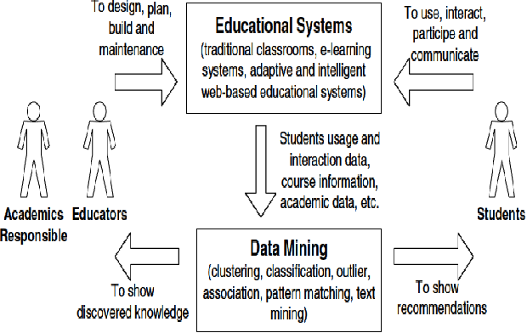 This process offers essential insights, opening potentially new paths to follow. The advantages of knowing about it are that the public's behaviour of a company can occur with the reduction of costs, an increase of ROI, better use of opportunities, and greater predictability in the statistical models. They can use in several ramifications: neural networks, rule induction, decision trees, time series analysis, and visualization.

Figure 1 representation of a DM model for Educational System.

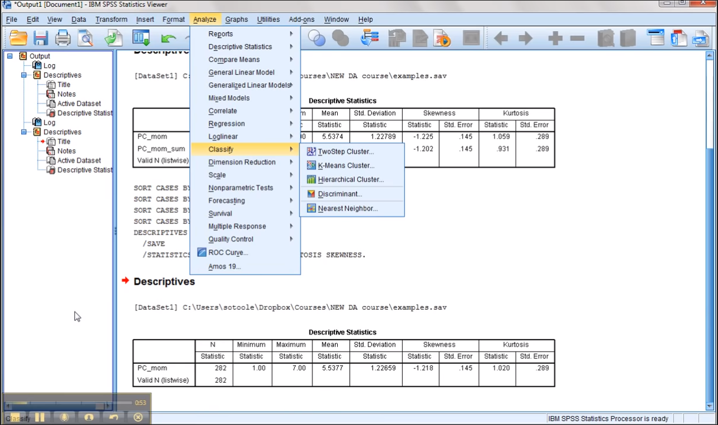Its cost reduction is related to the lower investment to reach the target audience of some business or tool. This set, the decrease in costs and conversion rates, will increase due to greater assertiveness and personalization of offers resulting in a greater return on investment. In ​​education, the implementation of the has been gaining great space in several market sectors, and in the educational scope, this is no different. There is an emerging field called Educational Data Mind. Whose application consists of developing methods and metrics to discover, analyse, map, and measure the knowledge of students and institutions and, consequently, help them trace the best paths in their academic lives. Educational, they also allow for rapid development of scientific knowledge about learning.

In addition, we can observe that the field of data analysis and statistics is very comprehensive. Different types of statistical analysis can follow different approaches, as in any programming project. A certain percentage of statistical analysis can be done using Excel or in a point and click approach such as SPSS, SAS, MATLAB or S-Plus (for example). A more sophisticated analysis using one of these programs (or R) that involves programming is a form of software development. Furthermore, this kind of statistical computing can benefit immensely from following all software development best practices: source control, documentation, project plan, scope document, bug tracking/change control, and so on. An automated tool would be beneficial for an organization, considering the level of priority and goals expected for this department. If the solution meets some business need, then the algorithm or software used is really of secondary importance as long as the program works the way the specifications require. On the other hand, accuracy and reproducibility are paramount with scientific and statistical computing.

Figure 2 IBM SPSS Statistical Editor interface, example of automated tool.

We can say that we would be overestimating something unlikely in the medium-term regarding data mining automation. However, maybe we underestimated something that would be a trend for the future. As Amara’s Law (2017) says, “We see this play out repeatedly with technologies ranging from trains to the internet to now machine learning. The trend is nearly always the same: initial, wildly optimistic claims about the capabilities of innovation are followed by a period of disillusionment when it fails to deliver before finally, we figure out how to use the technology, and it goes on to fundamentally reshape our entire world (this is known as the hype cycle).”

We cannot predict whether a profession will be permanently irreplaceable; what we know, based on what we have seen over the years, is that people adapt and find other forms of work, which would be most important for survival. Nevertheless, it is a rather delicate concept to automate, fully thinking about data analytics. It was impossible, but it is a little early today to let automation control the situation. We see much promise but few deliverables. There is a big gap between what data science can do and what is portrayed in the media. Data science is not a cure-all, and deploying machine learning models into production requires a highly unusual combination of the correct data and experience to use it. The truth is that companies' most prominent value is just visualizing data currently hidden in spreadsheets (or automating simple spreadsheet tasks with a bit of Python). Most companies do not have the resources or need for deep learning. So then, they avoid the hype train or risk losing confidence when they cannot deliver.

## Are outliers present in the above data set? Provide a strategy of removing outliers from the data set.

Before starting the cleaning and repairing the dataset, knowing how to collect some essential information to start the process, such as checking the types of variables, count, zeros, missing values and Nas and consequently the outliers, is always a good practice. As we can see with the output of the skimr function, the dataset is consistent, with variables in their correct types:

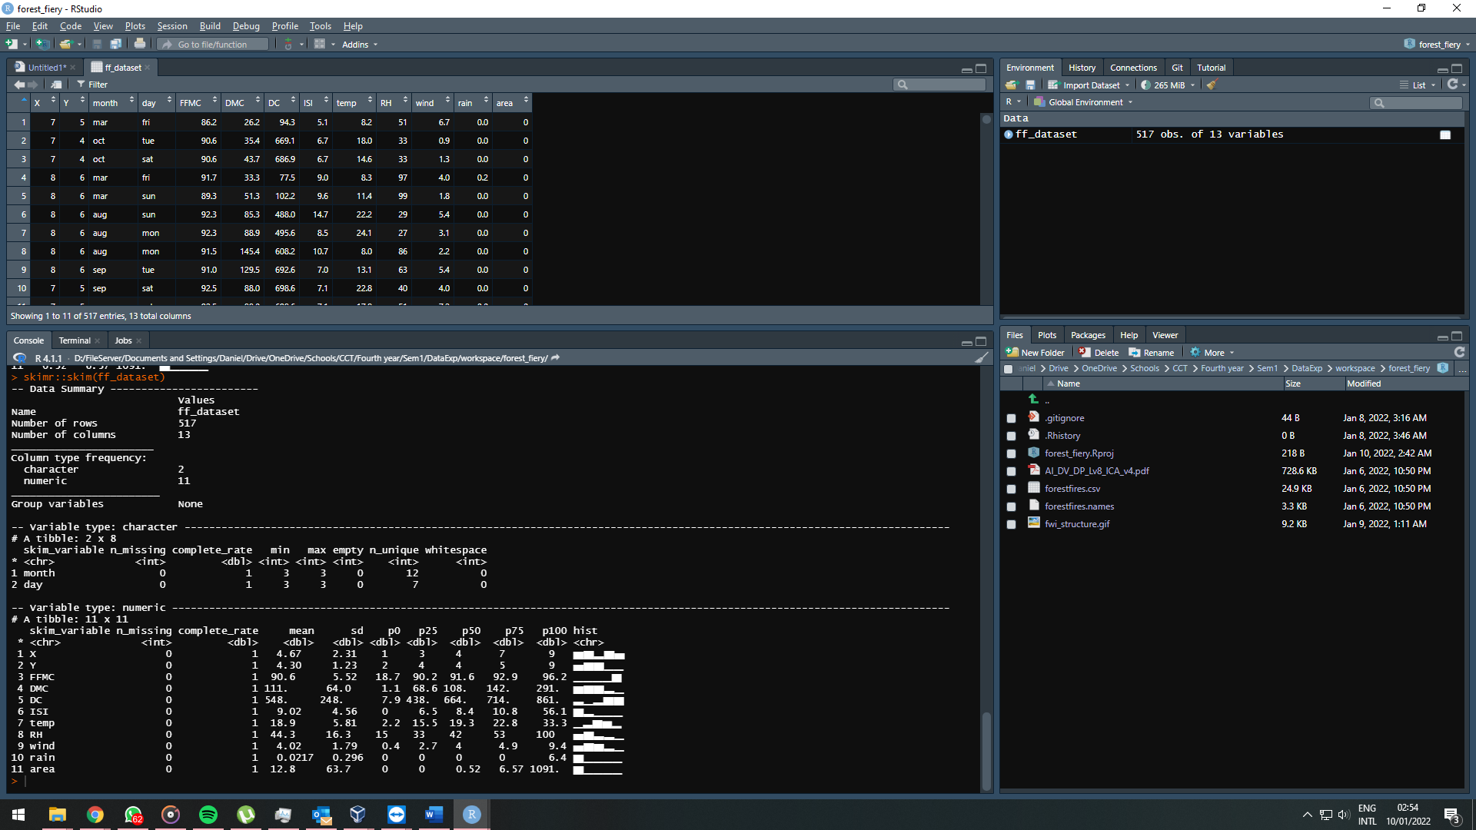

Figure 3 Output Skimr Function.

We can see a similar result with the glimpse function:

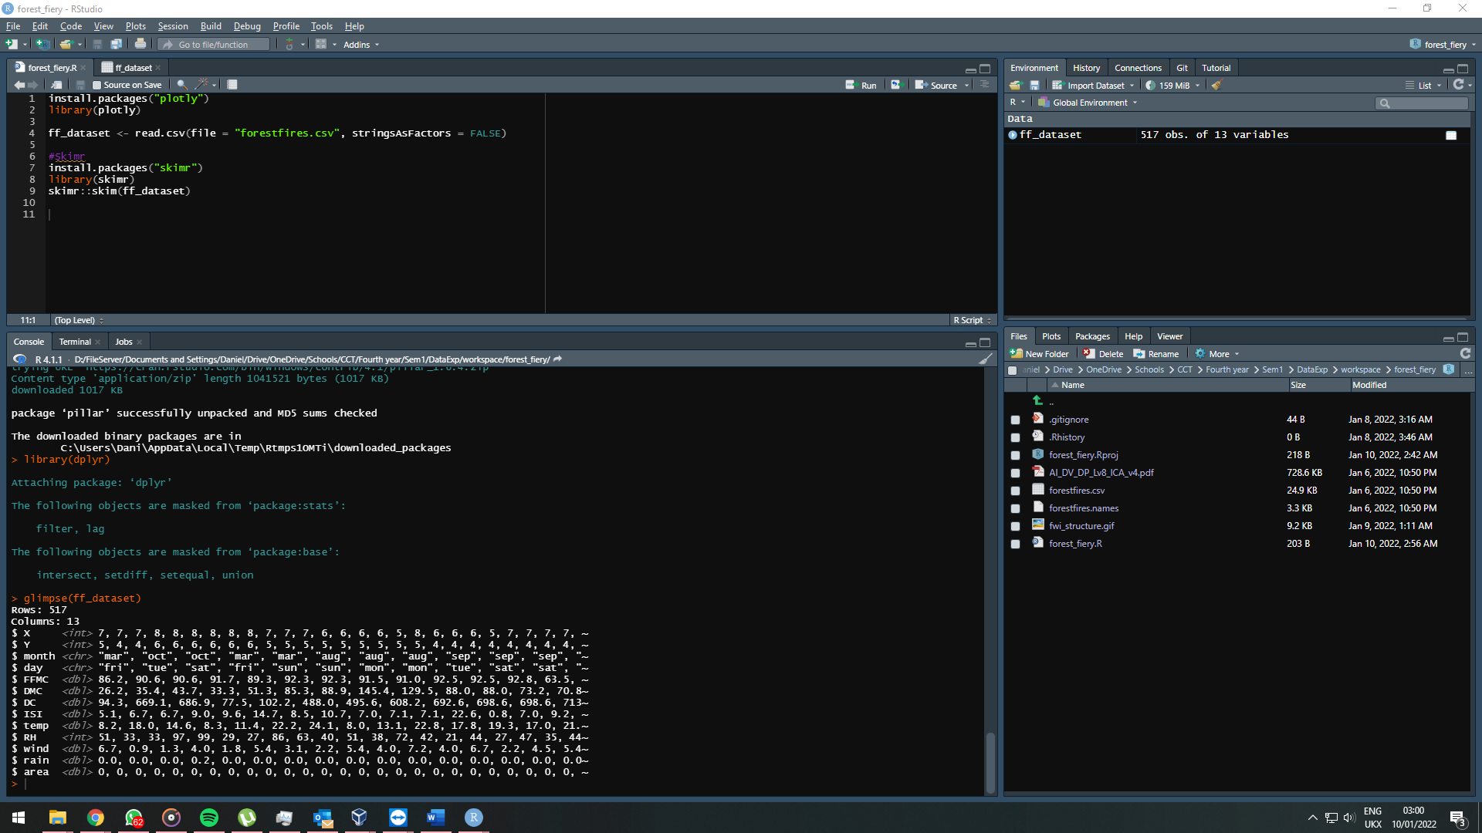

Figure 4 Glimpse function output to gather information from the dataset.

At first the histogram view to identify unusual or incorrect values remains without apparent flaws.

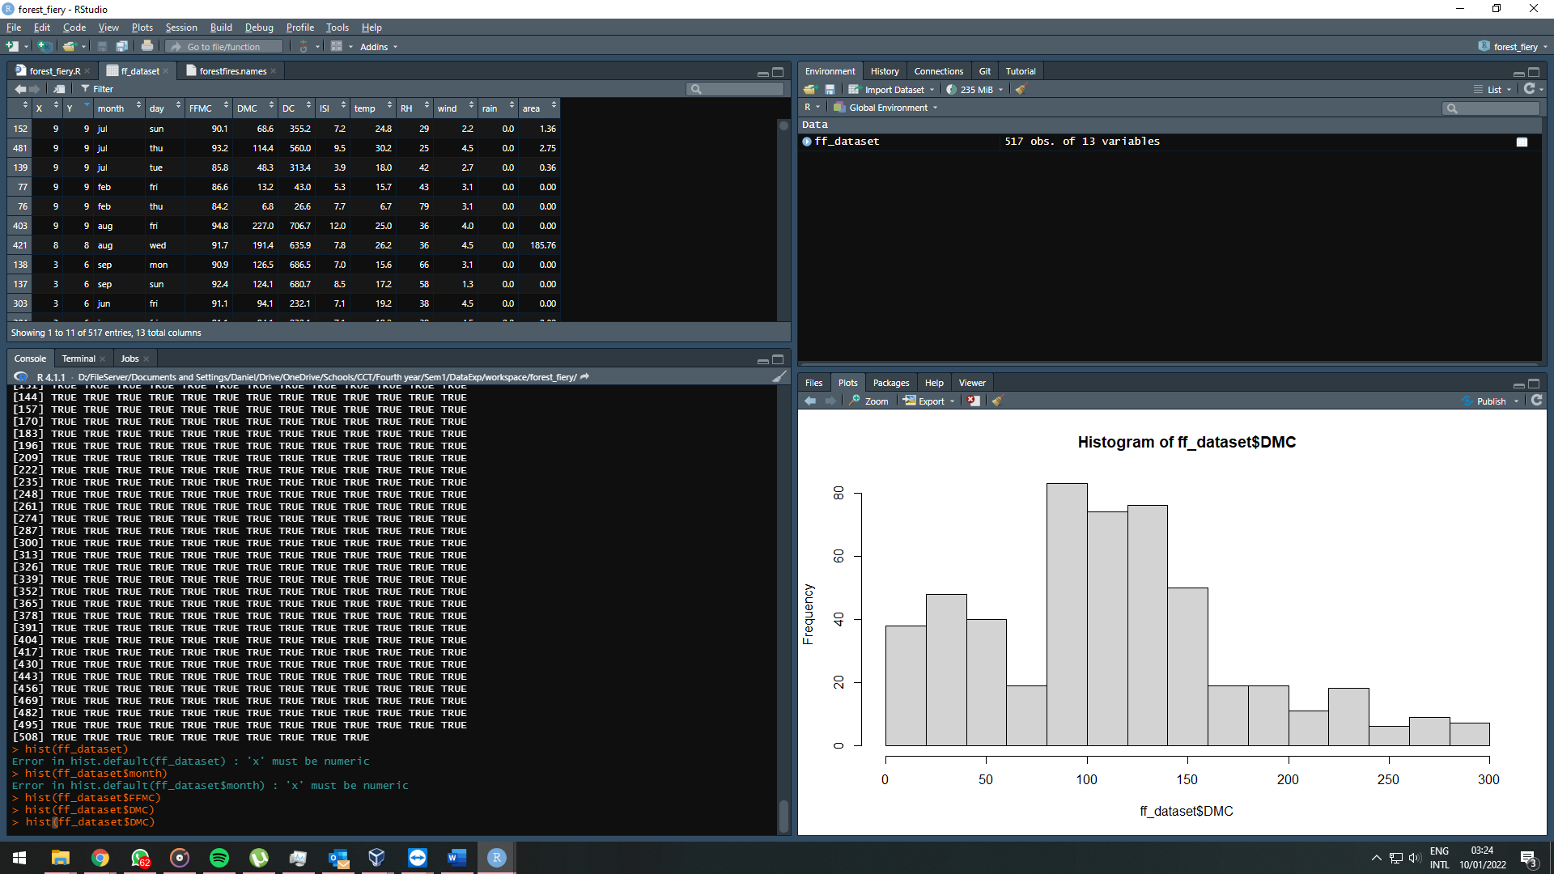

Figure 5 Histogram Plot from frequency of Fine Fuel Moisture Code (FFMC).

Evidence of outliers contained in the original data frame, let us start the renewal of these outliers:

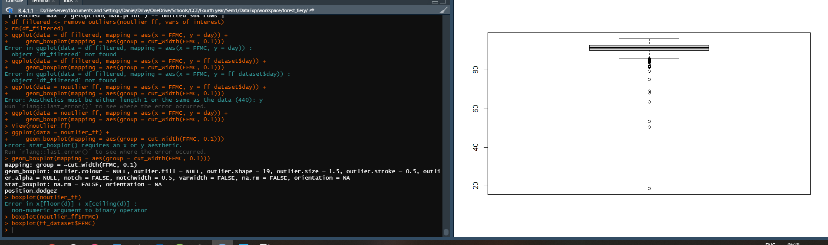

Figure 6 BoxPlot of the original data frame, confirming the presence of outliers.

After removing the outliers, we can understand in more detail the numerical values that are between Quantile 1 and 3:

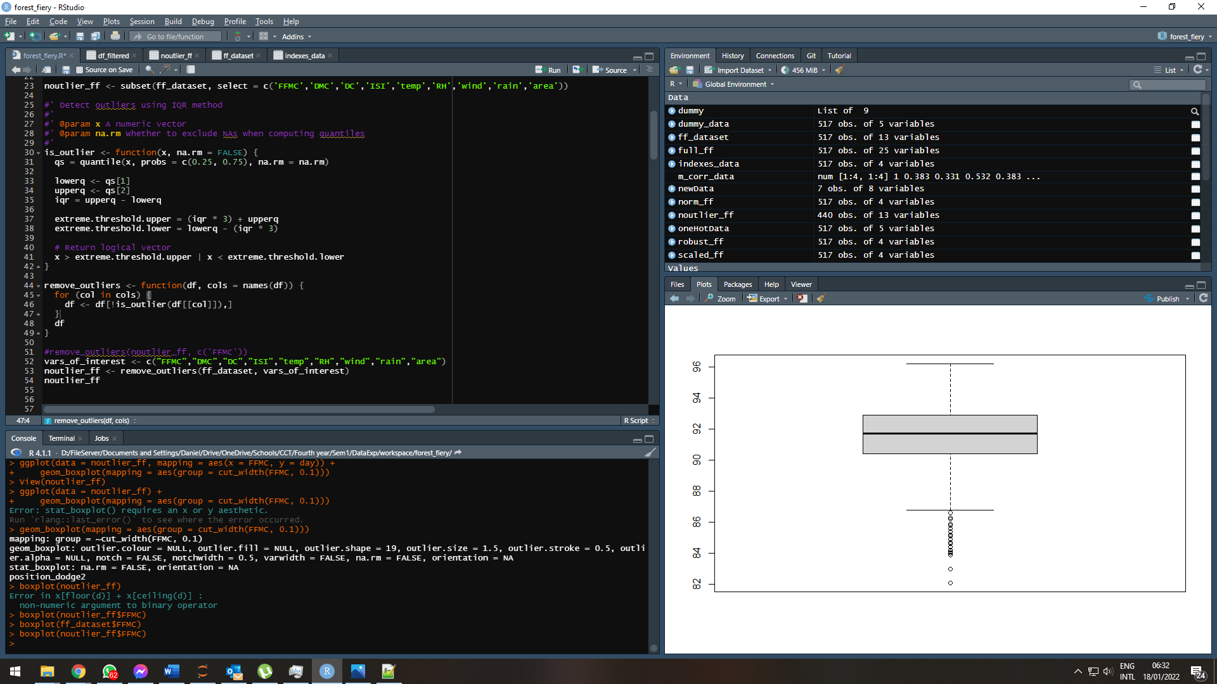

Figure 7 BoxPlot after performing outlier removal.

Another BoxPlot showing FFMC average incidents.

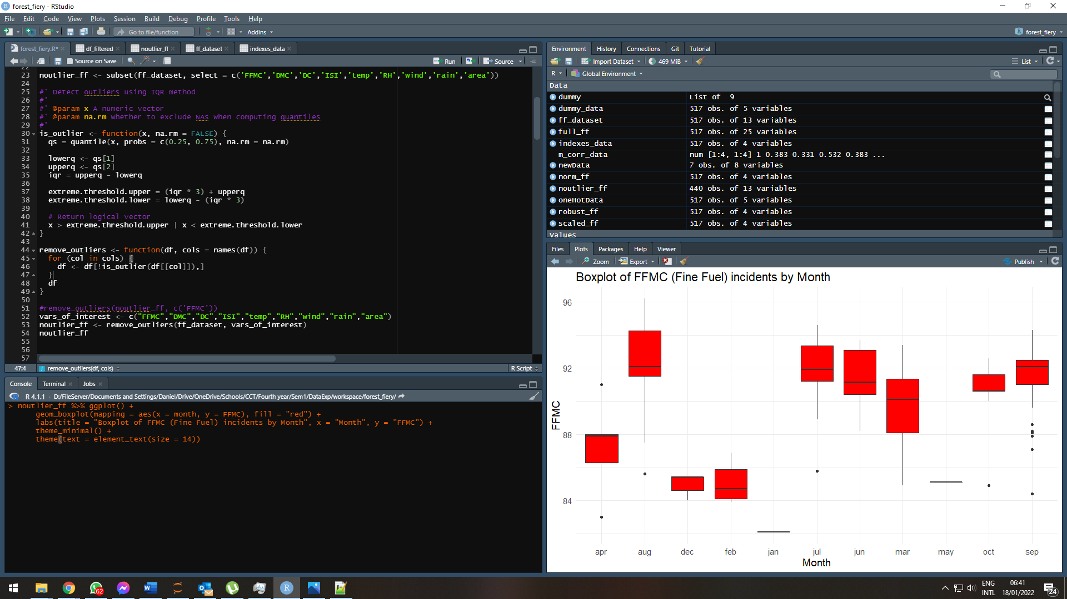

Figure 8 Boxplot of FFMC (Fine Fuel) incidents by Month.

## Choose a relevant encoding technique to transform the categorical data to numeric format

The encoding process is pretty straightforward to produce. However, this process is essential if we want to work with Machine learning because it reduces the scaling and memory overload, helping to process this information faster. The code used is also available in the script file:

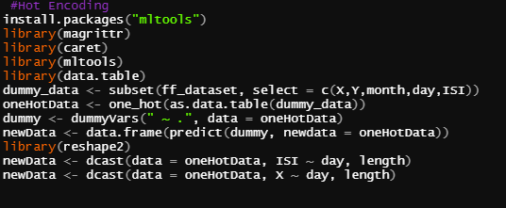

Figure 9 One Hot Encoding source code (R)

A view of Hot Encoding being applied to the day variable being compared to the month.

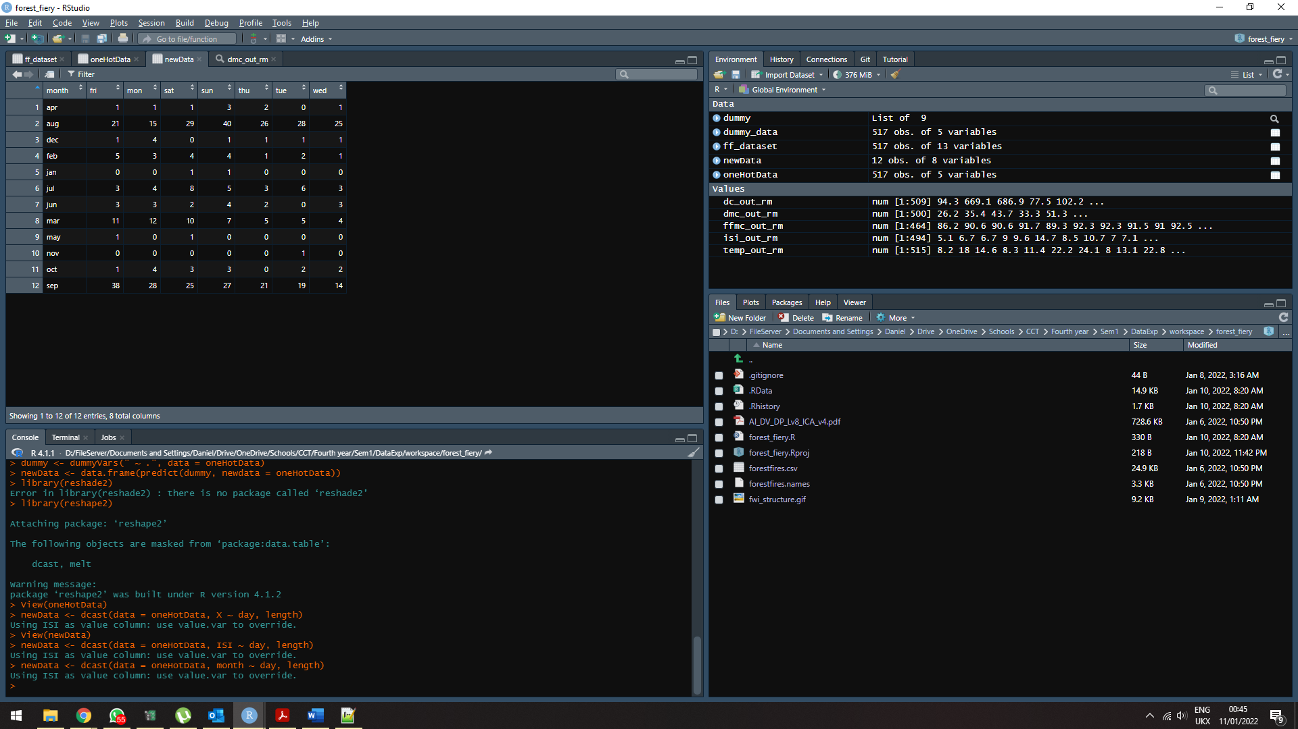

Figure 10 One Hot Encoding being applied to Day variable.

Another view of the Hot Encoding being applied to the day variable compared to the ISI (Initial Spread Index).

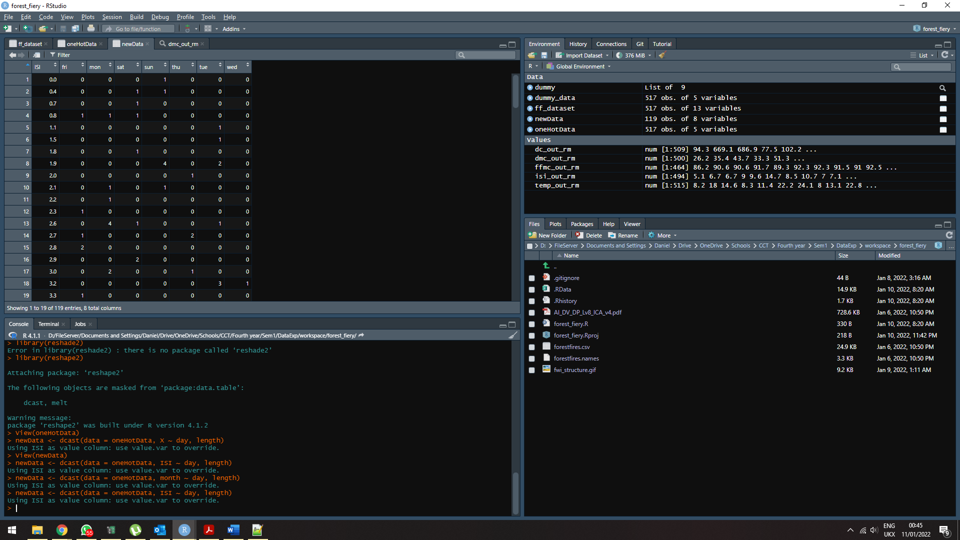

Figure 11 One Hot Encoding being applied to Day variable comparing with ISI index.

The last Hot encoding visualization, variable Day being applied to itself.

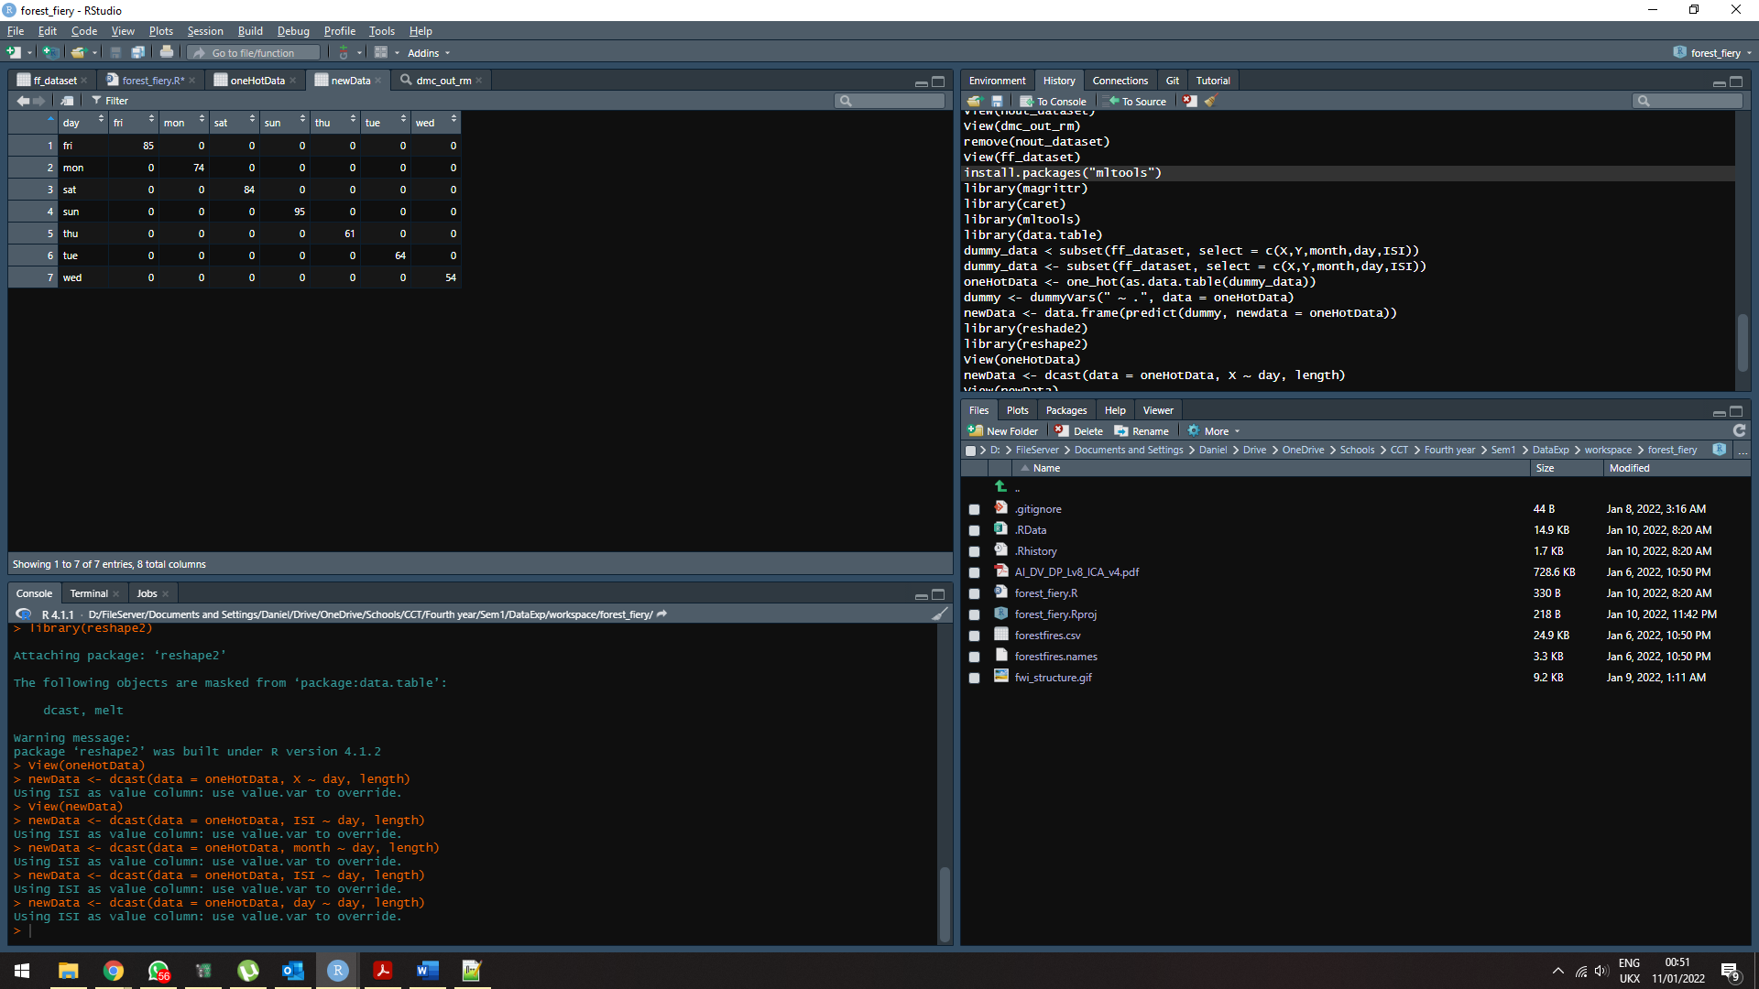

Figure 12 One Hot Encoding being applied to Day

* Formulate the questions for EDA (Exploratory Data Analysis) and perform EDA based on the data provided and address the issues to understand the impact of fire and the resulting burned area.

For a more customized summary, we installed the XDA package, which brings two very interesting functions for data exploration. These are the functions, numSummary and charSummary. as we can see, next:

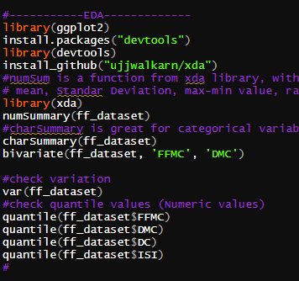

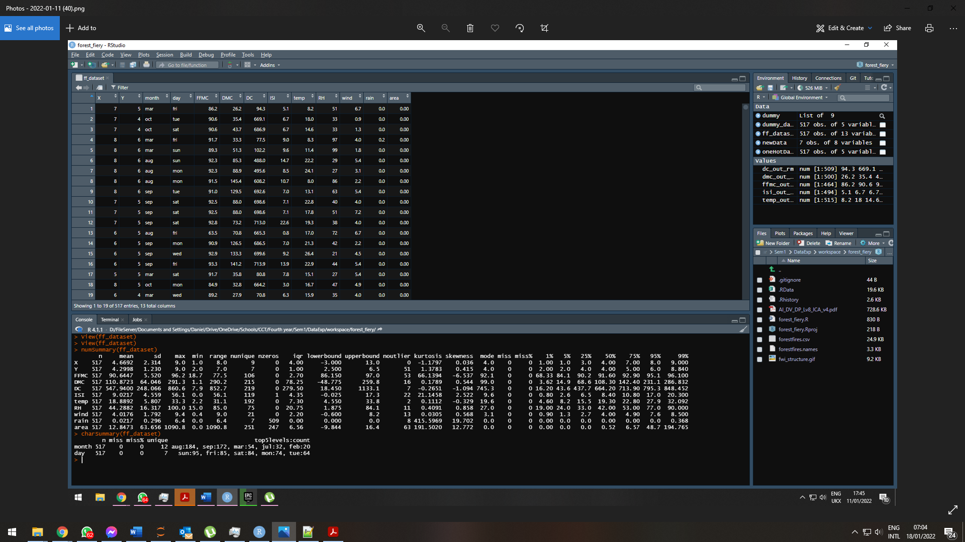

As part of the exploratory process, a grouping of Scatterplots was carried out to show the incidences of fires produced by the different methods listed (Fine Fuel, Organic Compound, Drought).

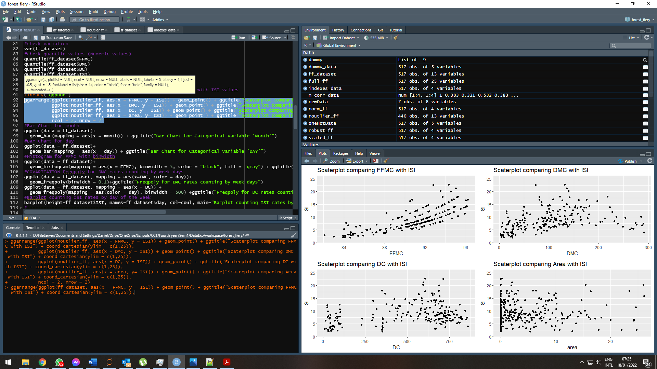

Figure 13 Grouping of 4 Scatterplots to show their incidences (FFMC, DMC, DC, ISI).

BarChart compares the number of incidents per month. With this, we can see the months with the most incidences.

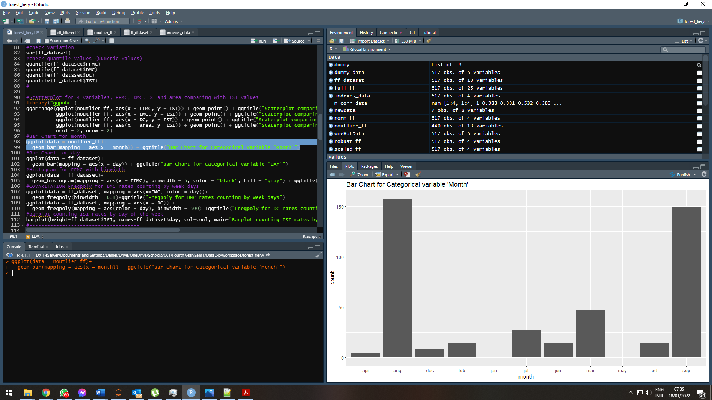

Figure 14 Bar Chart for Categorical variable 'Month' comparing with fire cases.

Days with more fire cases per week:

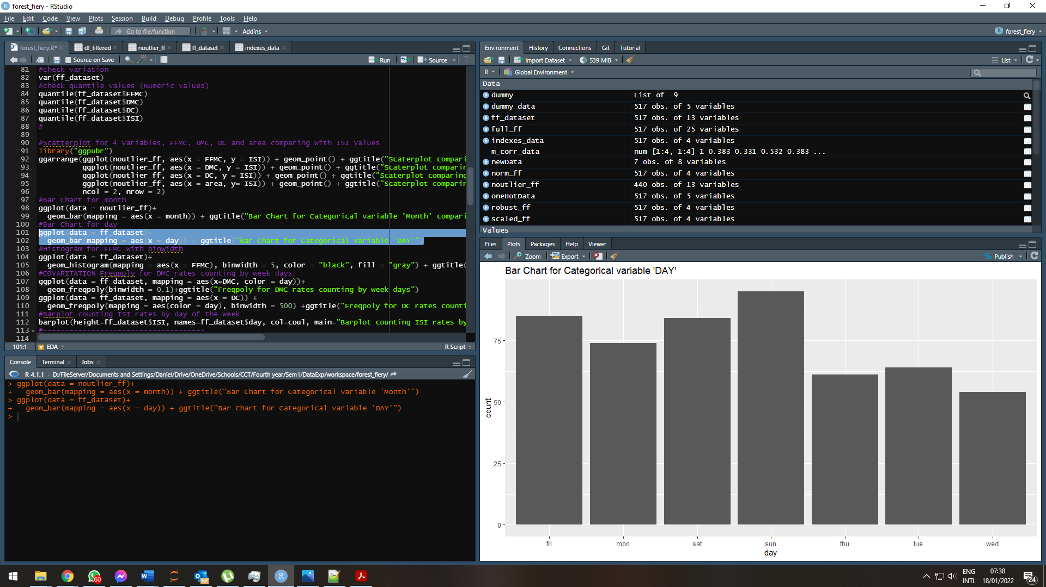

Figure 15 Bar Chart for Categorical variable 'DAY'.

Histogram Plot without outliers, makes it much better to view the plot.

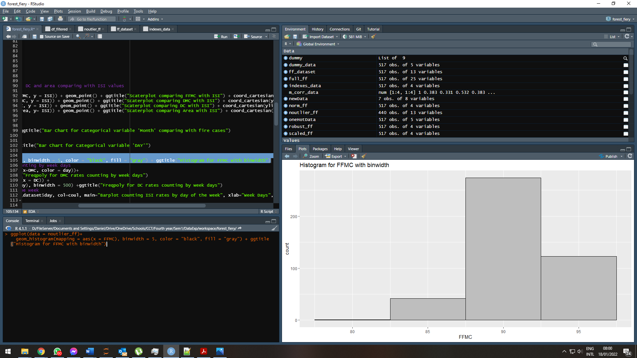

Figure 16 Histogram for FFMC with binwidth.

Identifying Covariation with Freqpoly plot for DMC rates counting by weekdays.

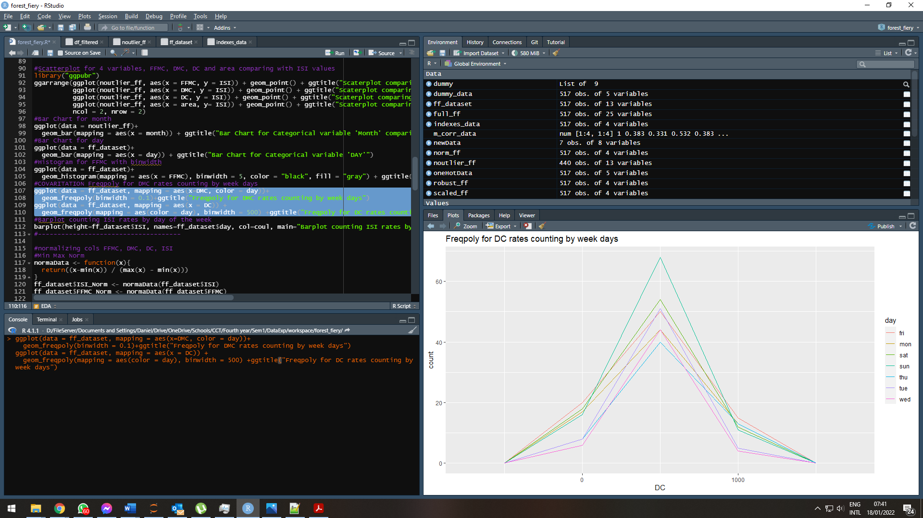

Figure 17 Freqpoly for DC rates counting by weekdays.

Barplot counting ISI index rates by day of the week

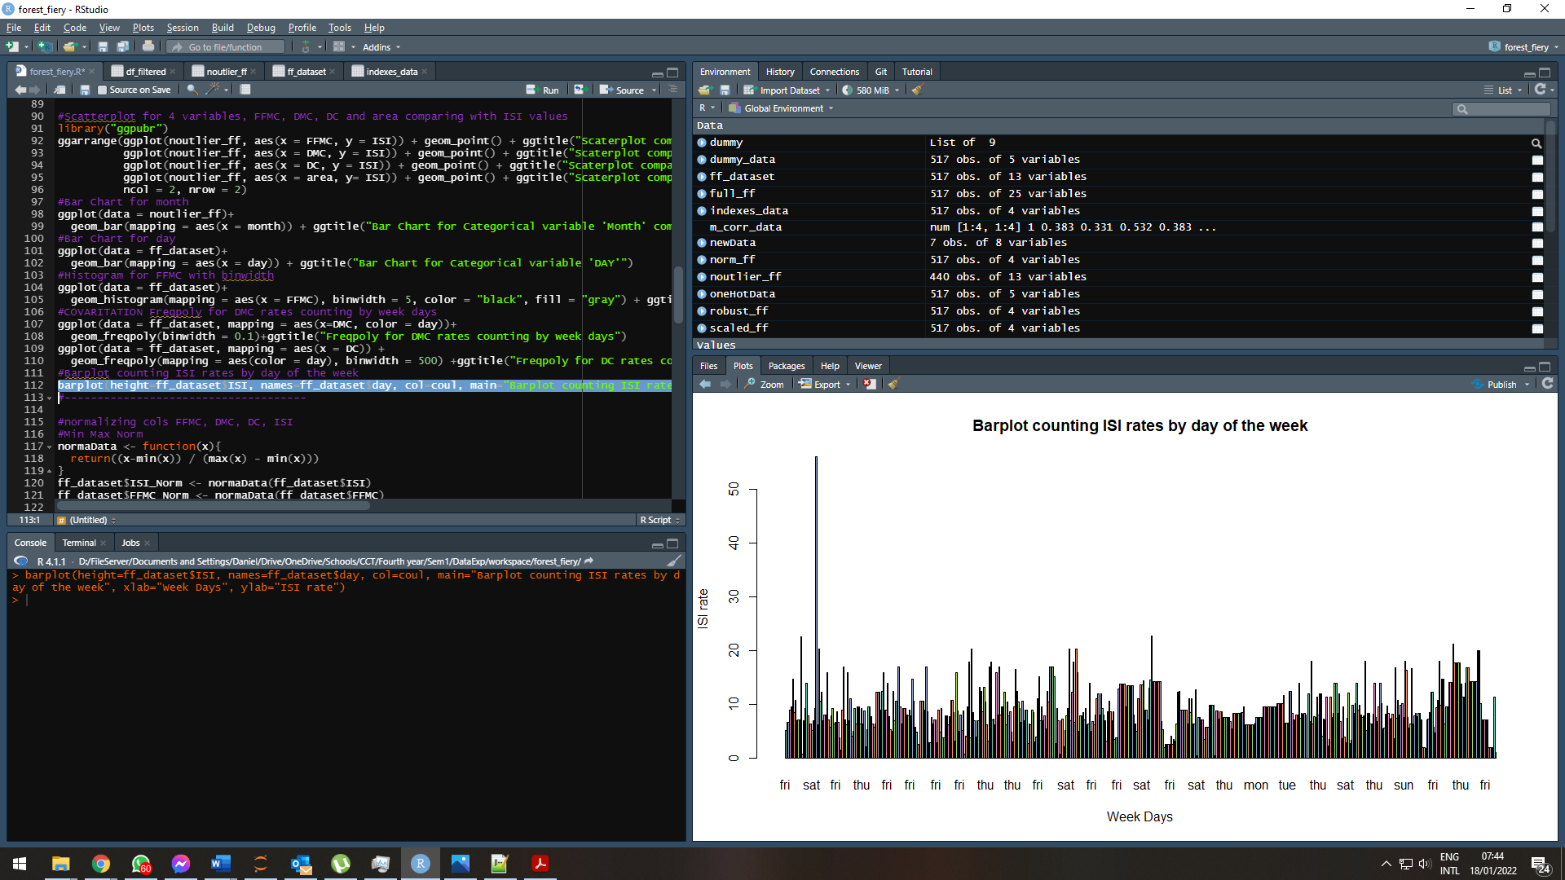

Figure 18 Barplot counting ISI rates by day of the week.

Minimum Maximum Normalization being applied for the following variables (FFMC, DMC, DC and ISI).

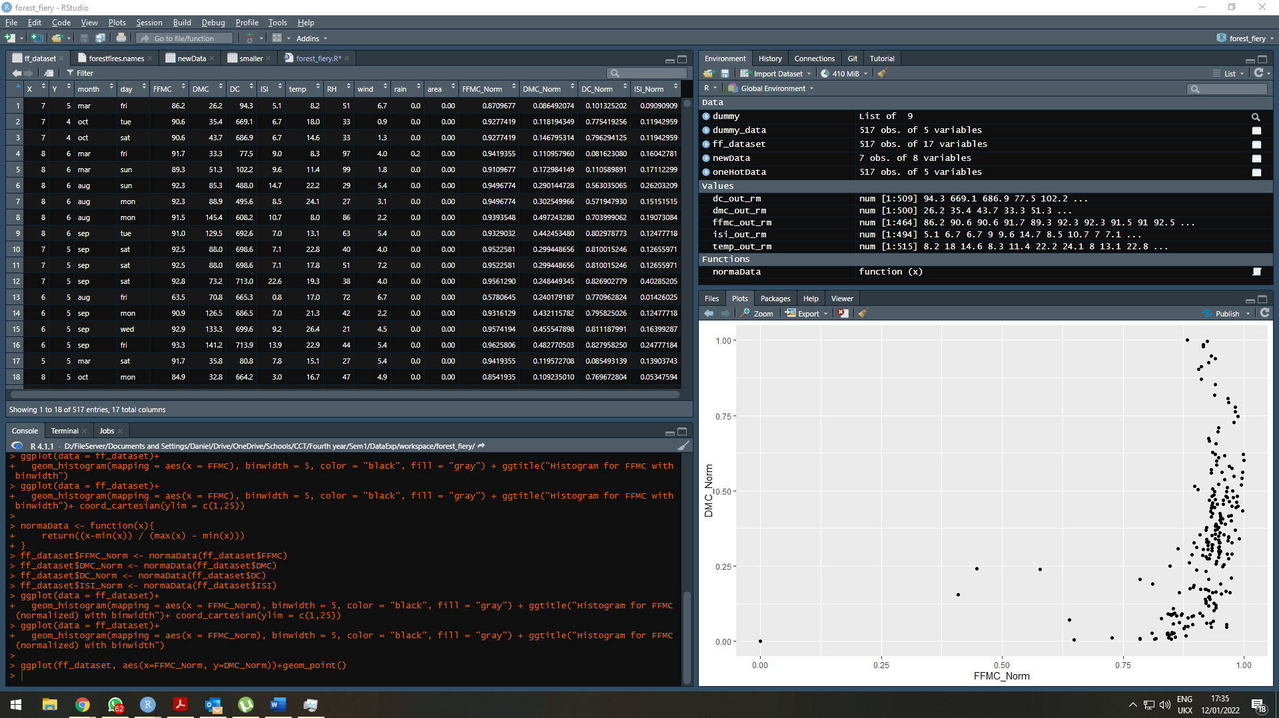

Figure 19 Creating Min-Max Normalization.

Z-Score being applied for the same variables above.

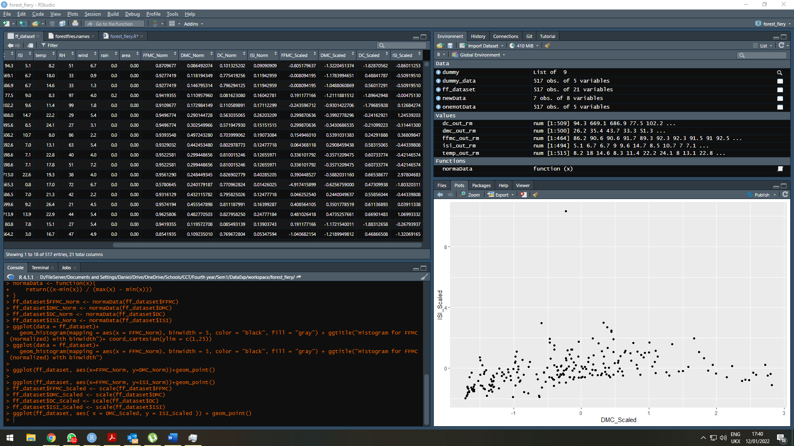

Figure 20 Creating Z-Score Scaling.

Robust Scalar being applied for the same variables above.

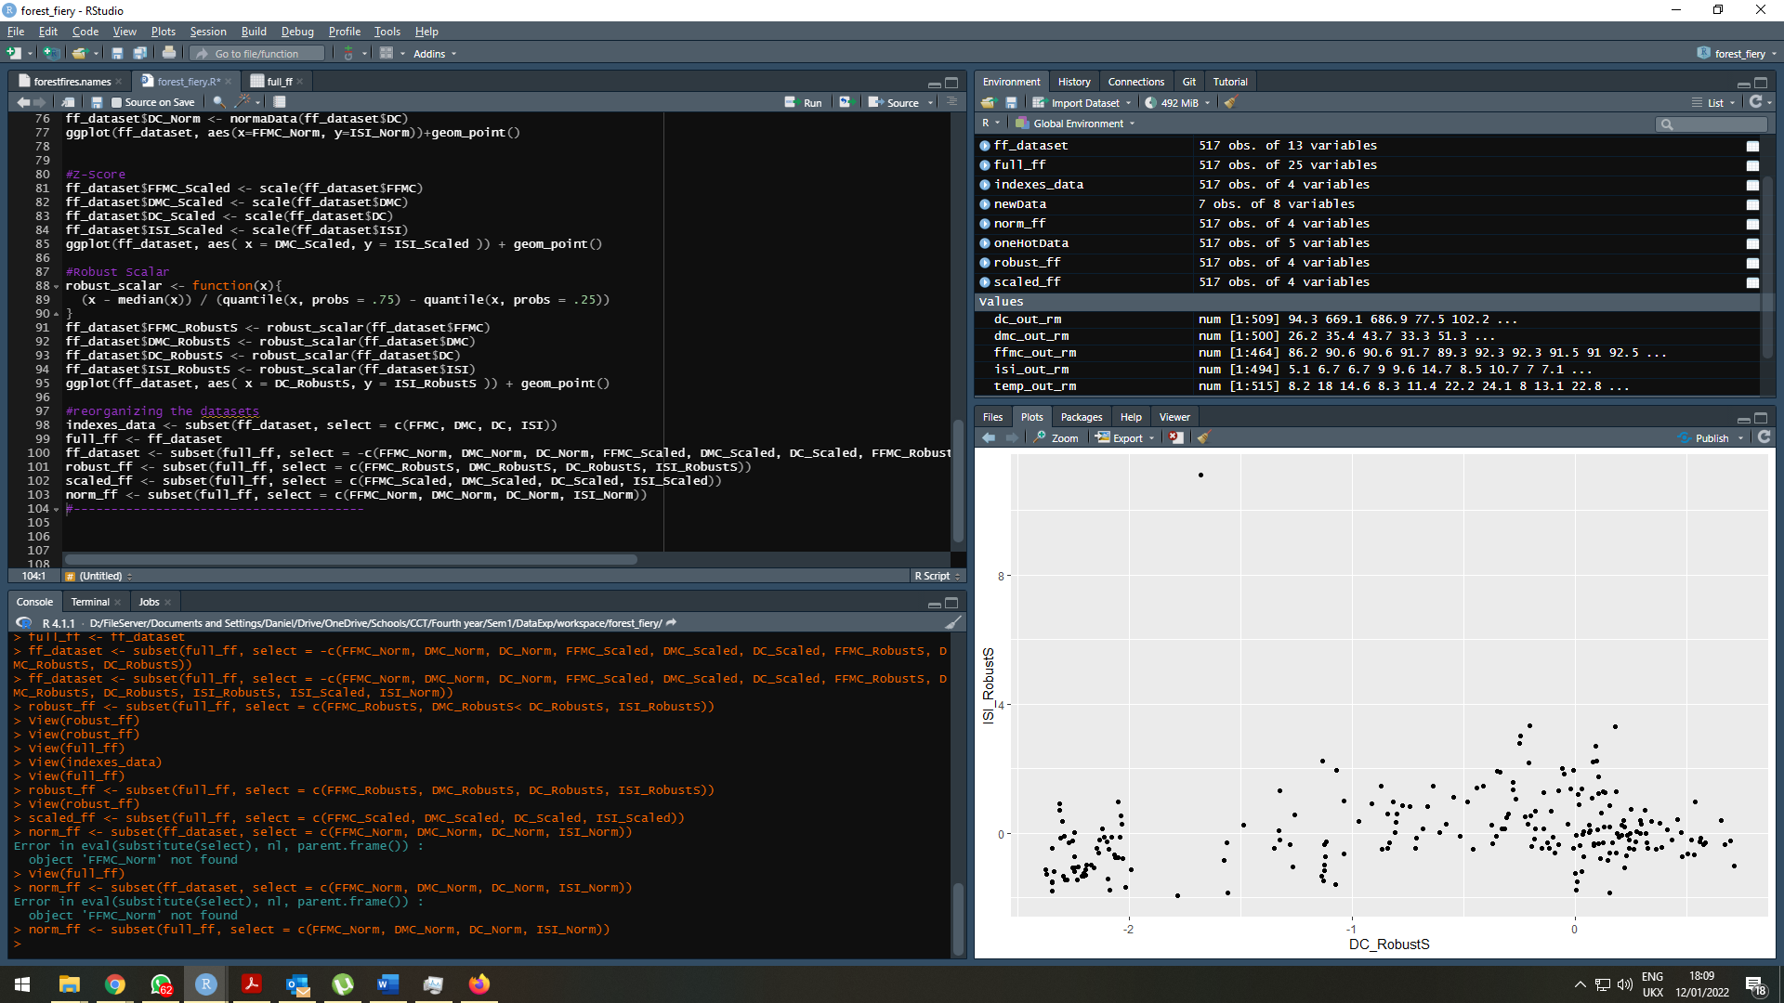

Figura 21 Creating Robust Scalar.

Ploting Line to analyse fuels indexes against ISI index, in Z-Score Scale.

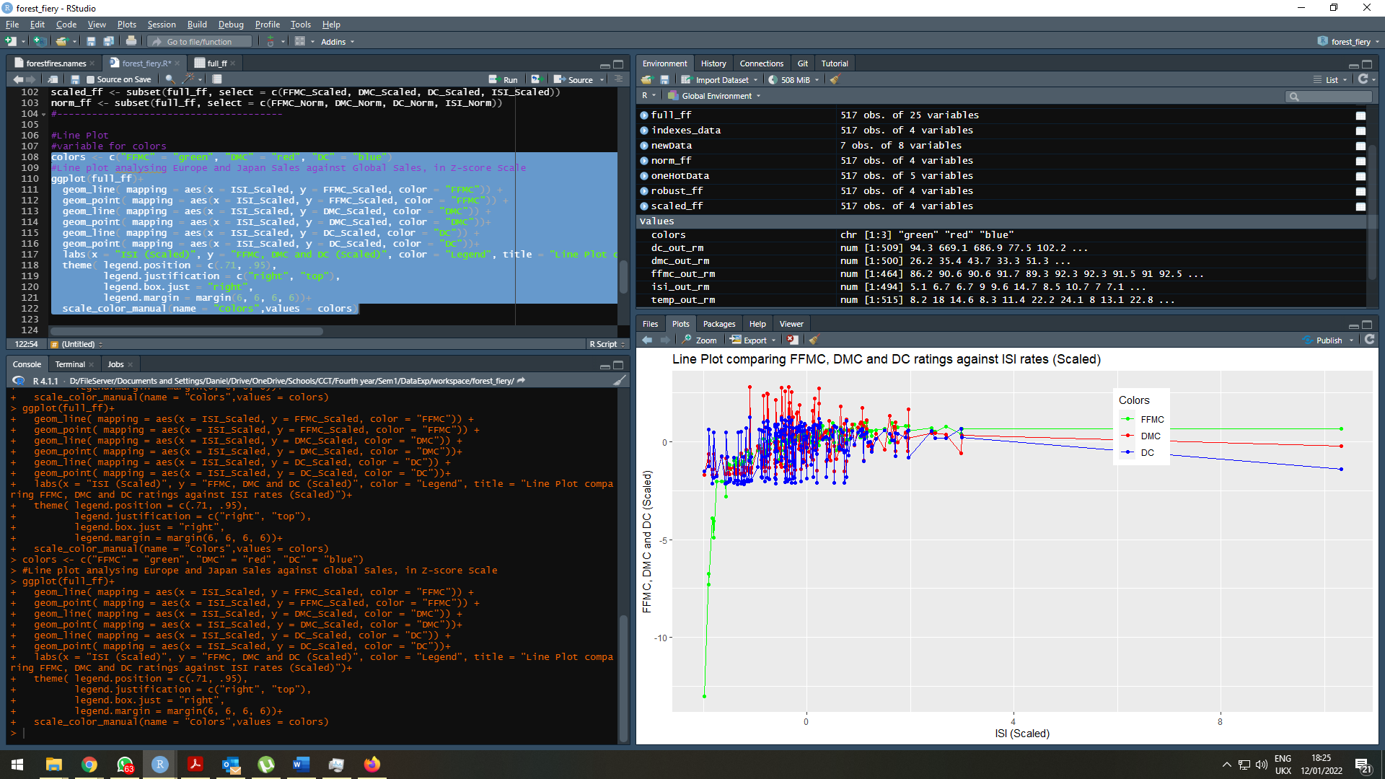

Figura 22 Line Plot comparing FFMC, DMC and DC ratings against ISI rates (Scaled)

Line plot analysing FFMC, DMC and DC against ISI rates, in Robust Scalar.

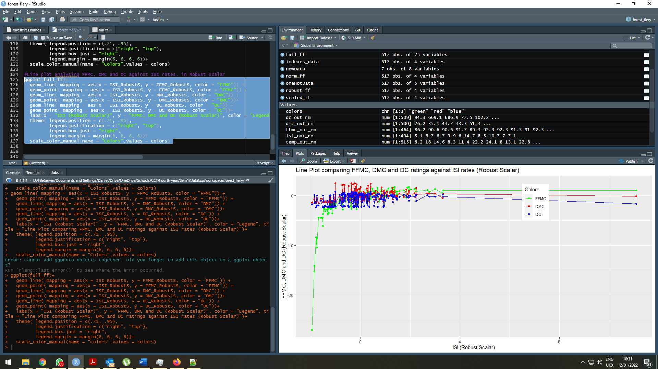

Figure 23 Line Plot comparing FFMC, DMC and DC ratings against ISI rates (Robust Scalar)

Scatterplot to see correlation between FFMC and DMC (robust scalar).

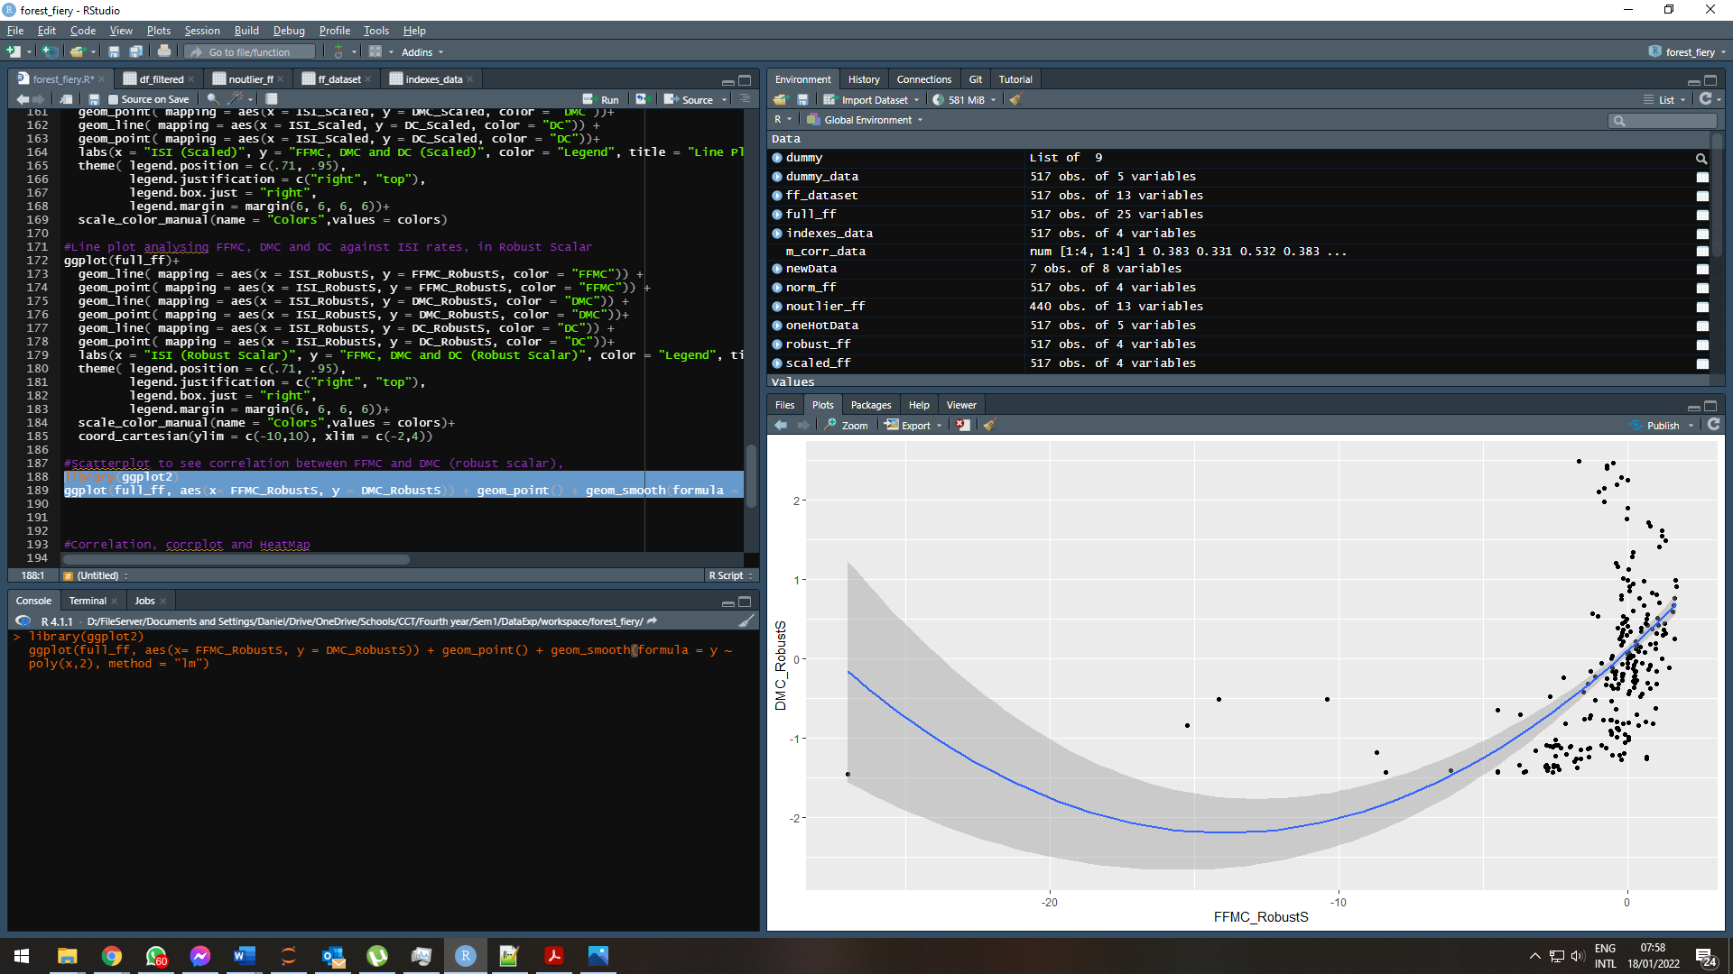

Figure 24 Scatterplot to see correlation between FFMC and DMC (robust scalar)

Correlation test using both methods as Pearson and Kendall.

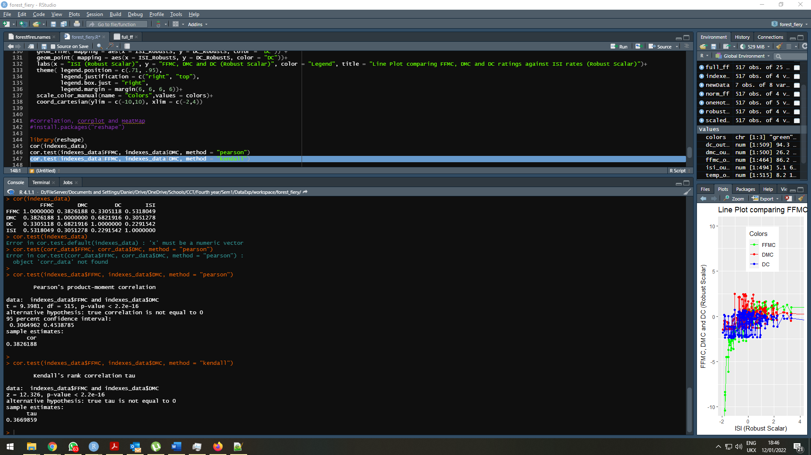

Figure 25 Correlation test using both known methods as Pearson and Kendall

Correlation Plot experimenting the variables, FFMC, DMC, DC and ISI

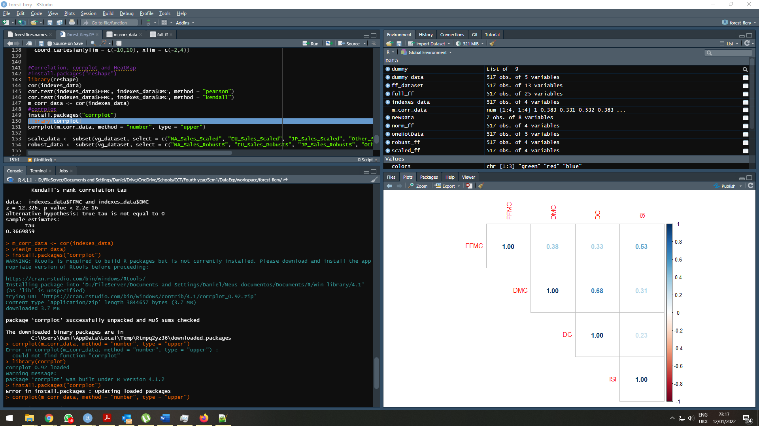

Figure 26 Correlation Plot experimenting the variables, FFMC, DMC, DC and ISI

HeatMap from the correlation data, here we have more visual to analyse the possible correlation between the variables.

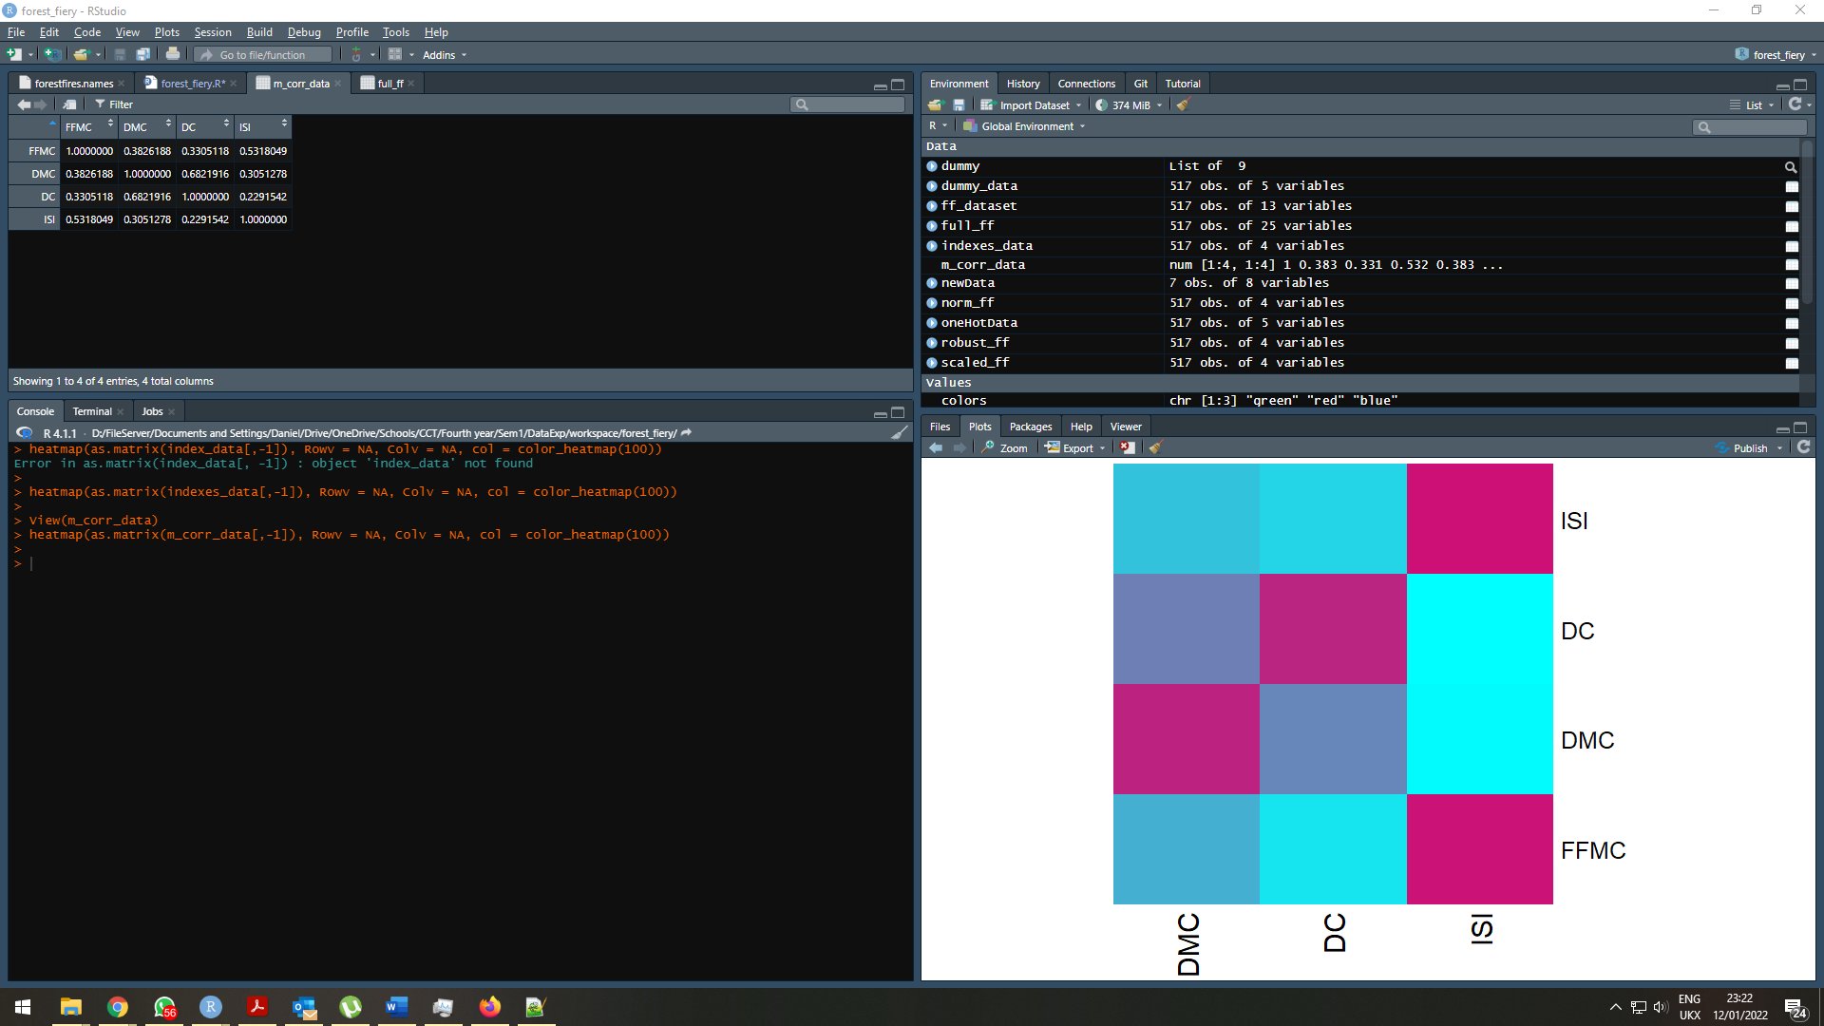

Figure 27 HeatMap from the correlation data

Stacked Bar Chart of FFMC fires by Day, grouping colours by weekday as well.

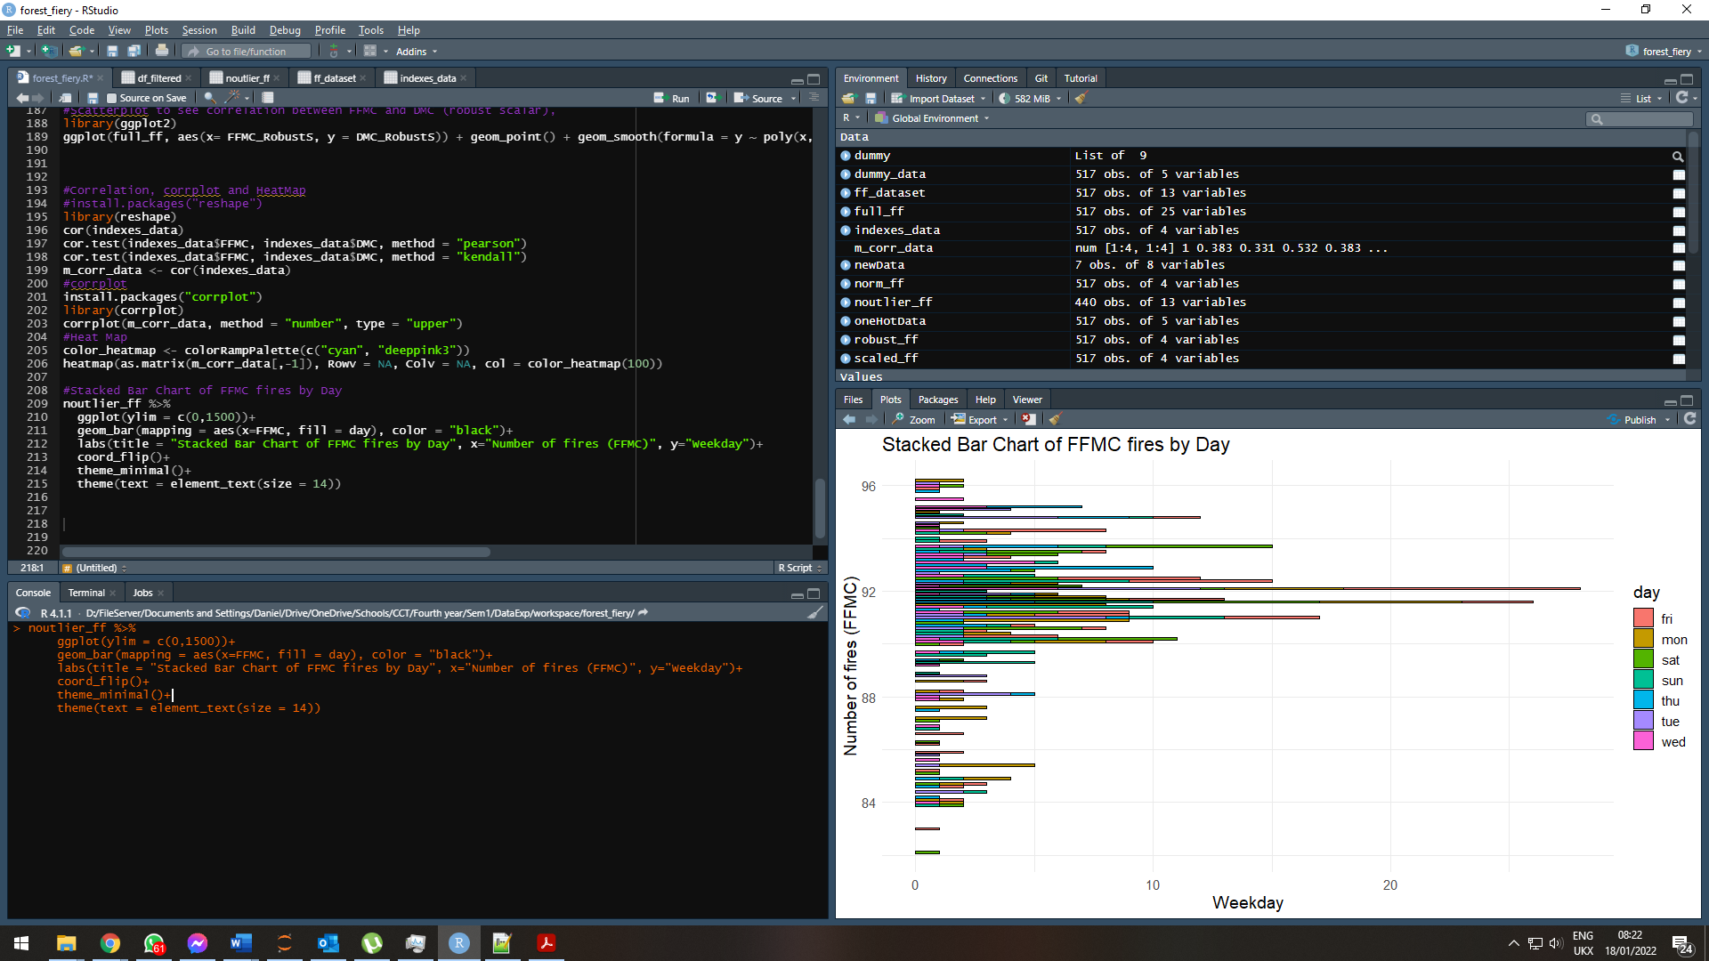

Figure 28 Stacked Bar Chart of FFMC fires by Day

## Explain the purpose of PCA (Principal Component Analysis) and how It is effective to reduce dimensionality of the dataset. Find two components of the above data set

Principal Component Analysis or PCA (Principal Component Analysis) is a multivariate analysis technique used to analyze interrelationships between many variables and explain these variables in terms of their inherent dimensions (Components). The objective is to find a way to condense the information contained in several original variables into a smaller set of statistical variables (components) with minimal loss of information. In Machine Learning, it is believed that the more the number of features, the better our prediction, but this is not always true. If we keep increasing the number of features after a certain point, the performance of our machine learning algorithm tends to decrease.

According to the Hughes phenomenon, if the number of training samples is fixed and we keep increasing the number of dimensions, the predictive power of our machine learning model first increases, but after a certain point, it tends to decrease. If we continue to increase the number of dimensions, each feature can take on a range of possible values, so as the dimensions increase, we need to keep increasing the data samples to ensure that there are multiple samples with each combination of values. Typically, the number of samples needed for a good prediction increases logarithmically as to dimensions increase. In the real world, datasets have 1000 resources, so the amount of data we need to keep up with increasing dimensions becomes huge (2¹⁰⁰⁰), which increases training time drastically, on the other hand, if we keep increasing dimensions and if you do not increase the number of samples, our machine learning algorithms tend to adjust too much, and their performance ends up decreasing.

PCA is a linear dimensionality reduction technique that converts a set of correlated features in high-dimensional space into a series of uncorrelated features in low-dimensional space. These uncorrelated features are also called core components. PCA is an orthogonal linear transformation, which means that all principal components are perpendicular. It transforms the data so that the first component tries to explain the maximum variance from the original data. It is an unsupervised algorithm. That is, it does not take into account class labels.

We initialize the necessary libraries (FactorMiner and factorextra) in this first image and generate the first search components. We use the dataset's Z-Score variables to generate the results.

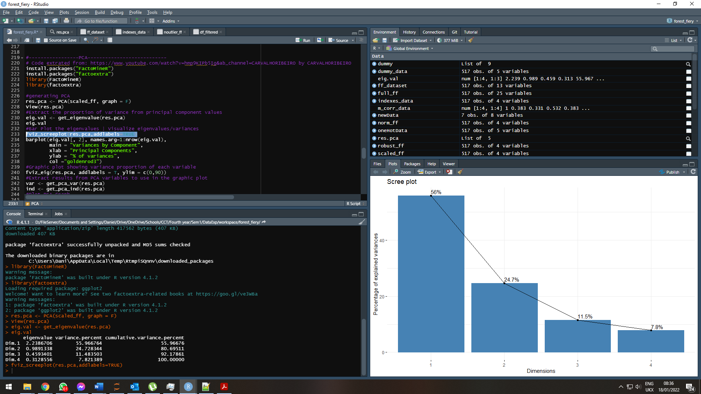

Figure 29 Generating PCA and Extracting the proportion of variance from principal component values.

In this part we use “get_eigenvalue(res.pca)” to extract the eigenvalues/variances of principal components

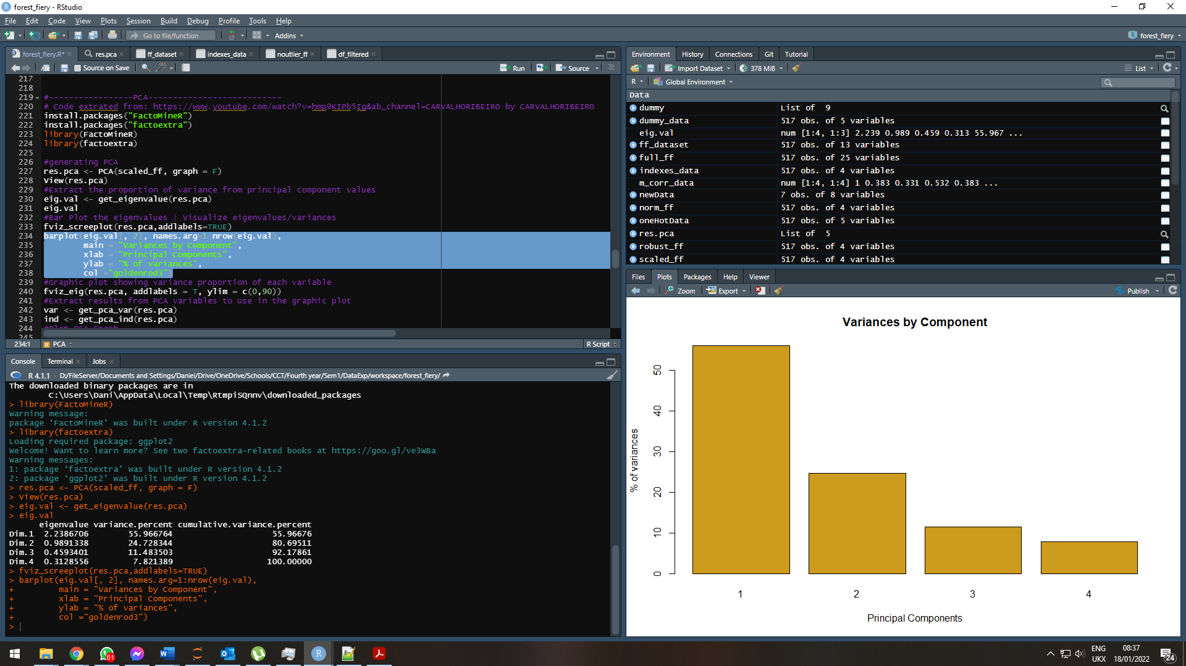

Figure 30 Bar Plot the eigenvalues | Visualize eigenvalues/variances

Graphic plot to visualize the eigenvalues.

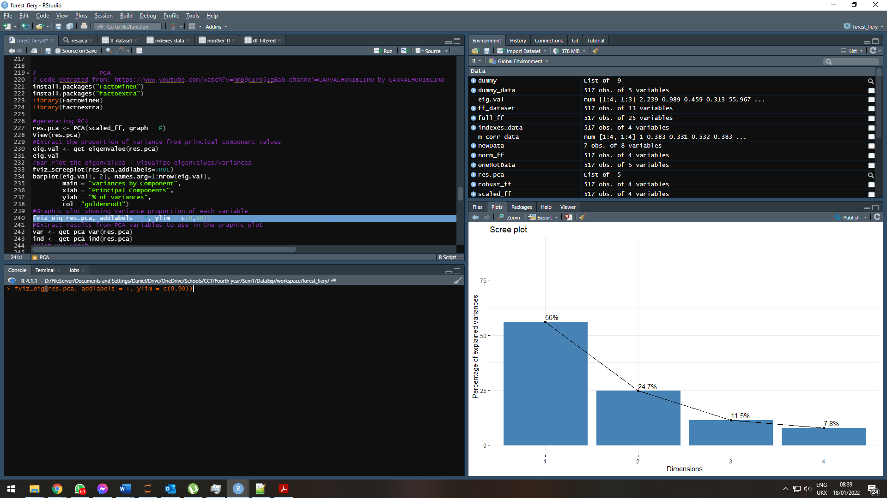

Figure 31 Graphic plot showing variance proportion of each variable.

Extract results from PCA variables to use in the graphic plot and Plot PCA Graph:

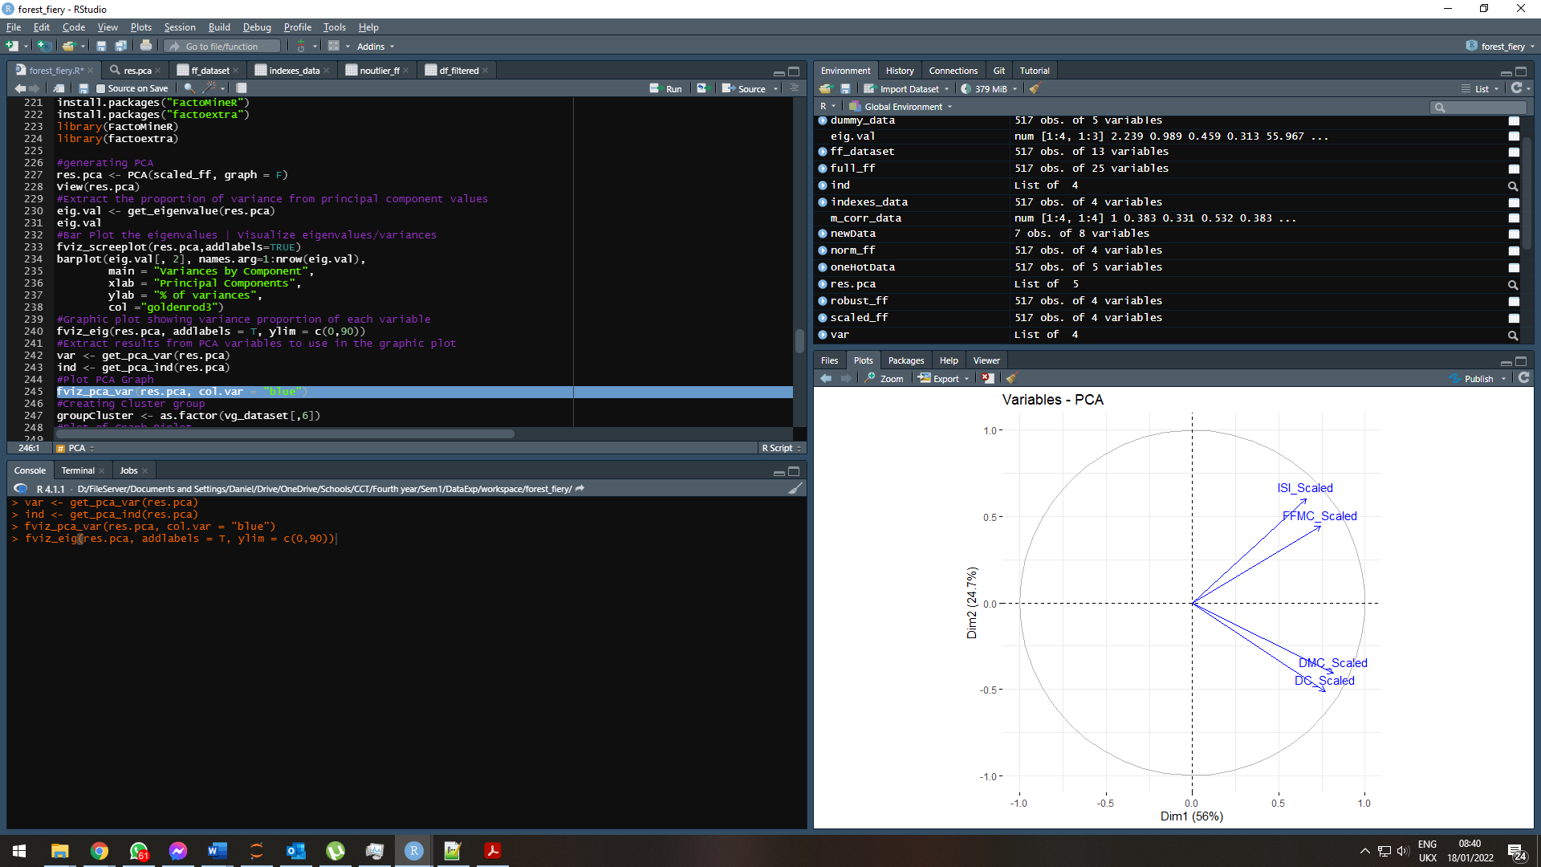

Figure 32 Extract results from PCA variables to use in the graphic plot and Plot PCA Graph and Plotting to the view.

Here is the outcome of the process (PCA). We extract the results for individuals and variables, create a cluster group and use Biplot to generate the graph.

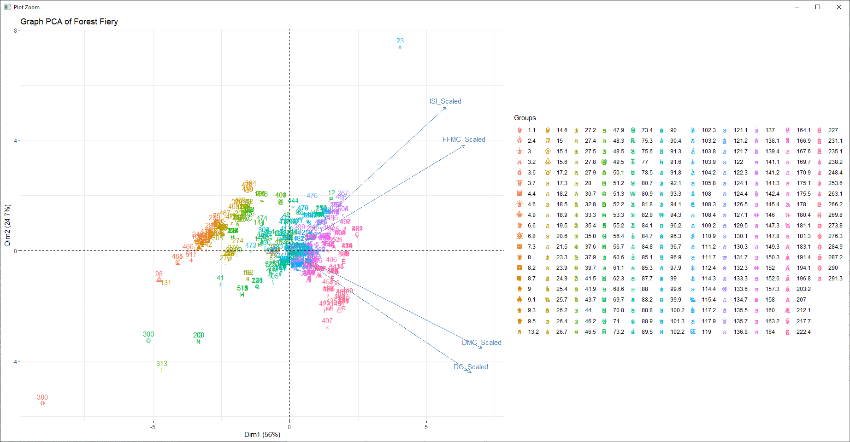

*Figura 33 Biplot mostrando o resultado do processo de PCA.*

Additional Plot to check the quality of the representation with COS2 and Graph.

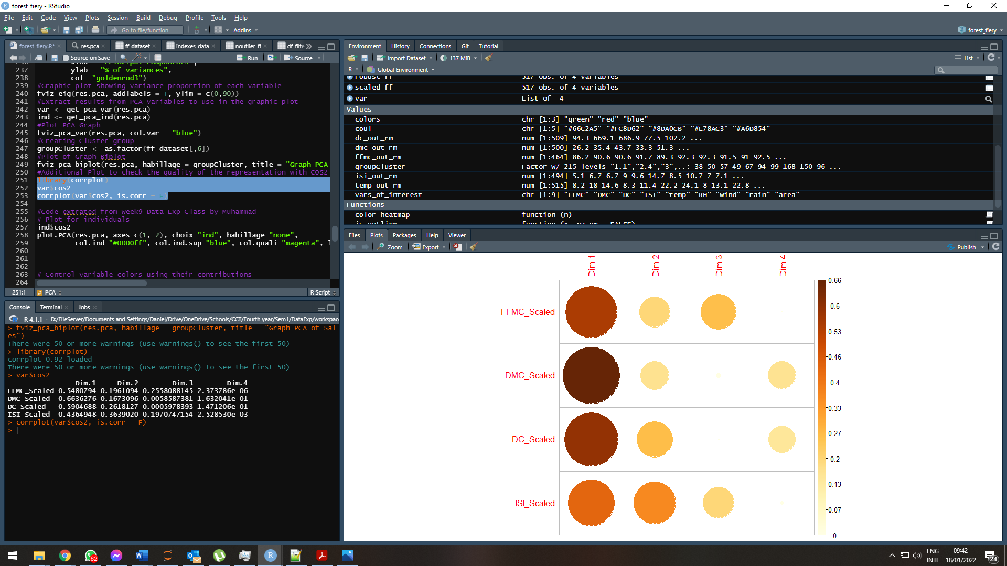

Figure 34 Additional Plot to check the quality of the representation with COS2 and Graph.

Plot for individuals

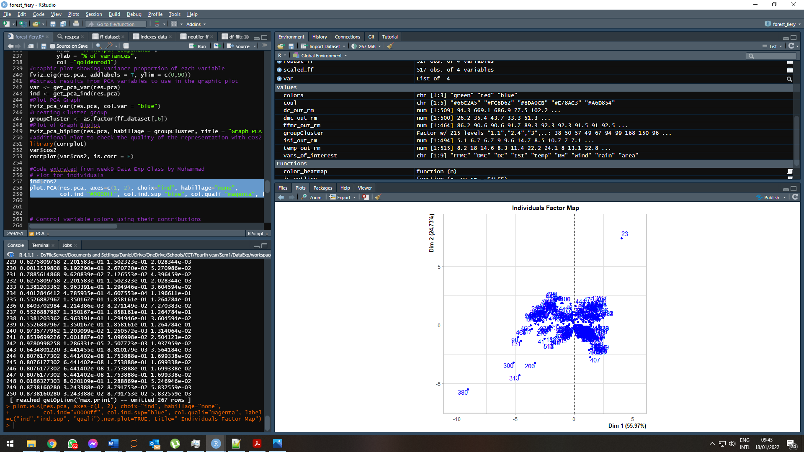

Figure 35 Plot for individuals

Control variable colours using their contributions, Using red and blue.

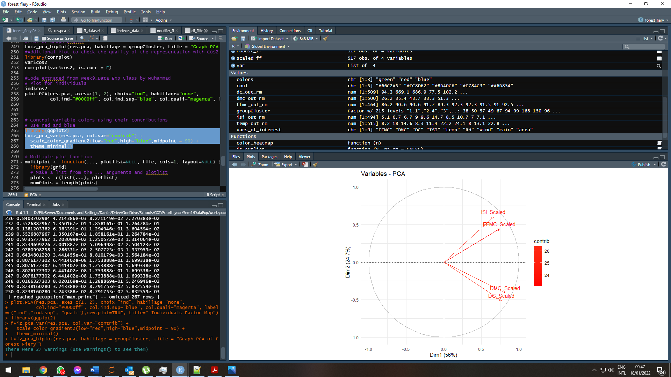

Figura 36 PCA Graph for the variables being studded.

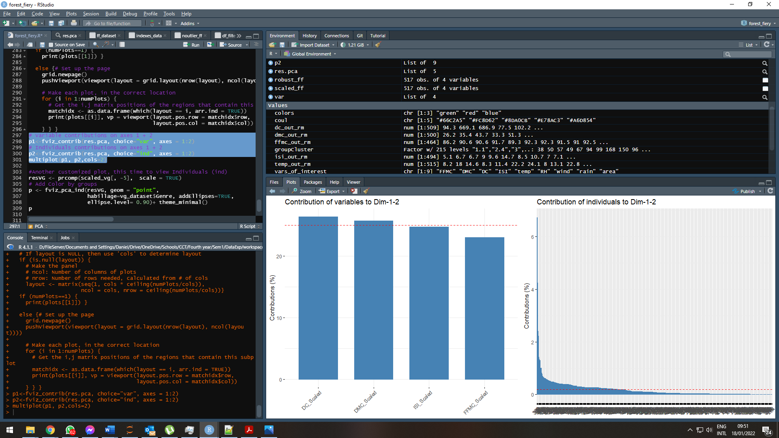

Figure 37 Variable and Individuals contributions on axes 1 + 2.

Another customized plot, this time to view Individuals (ind).

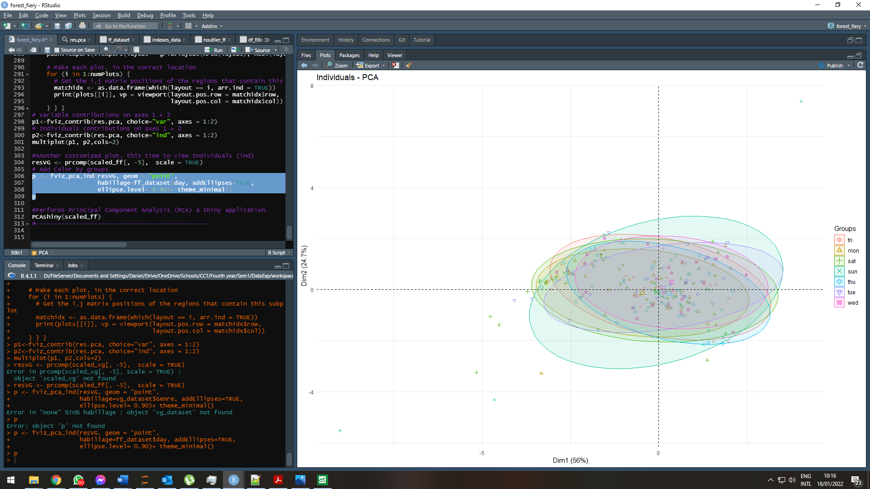

Figure 38 Another customized plot, this time to view Individuals (ind).

Used Factoshiny package to generate a customed PCA visualization of the results.

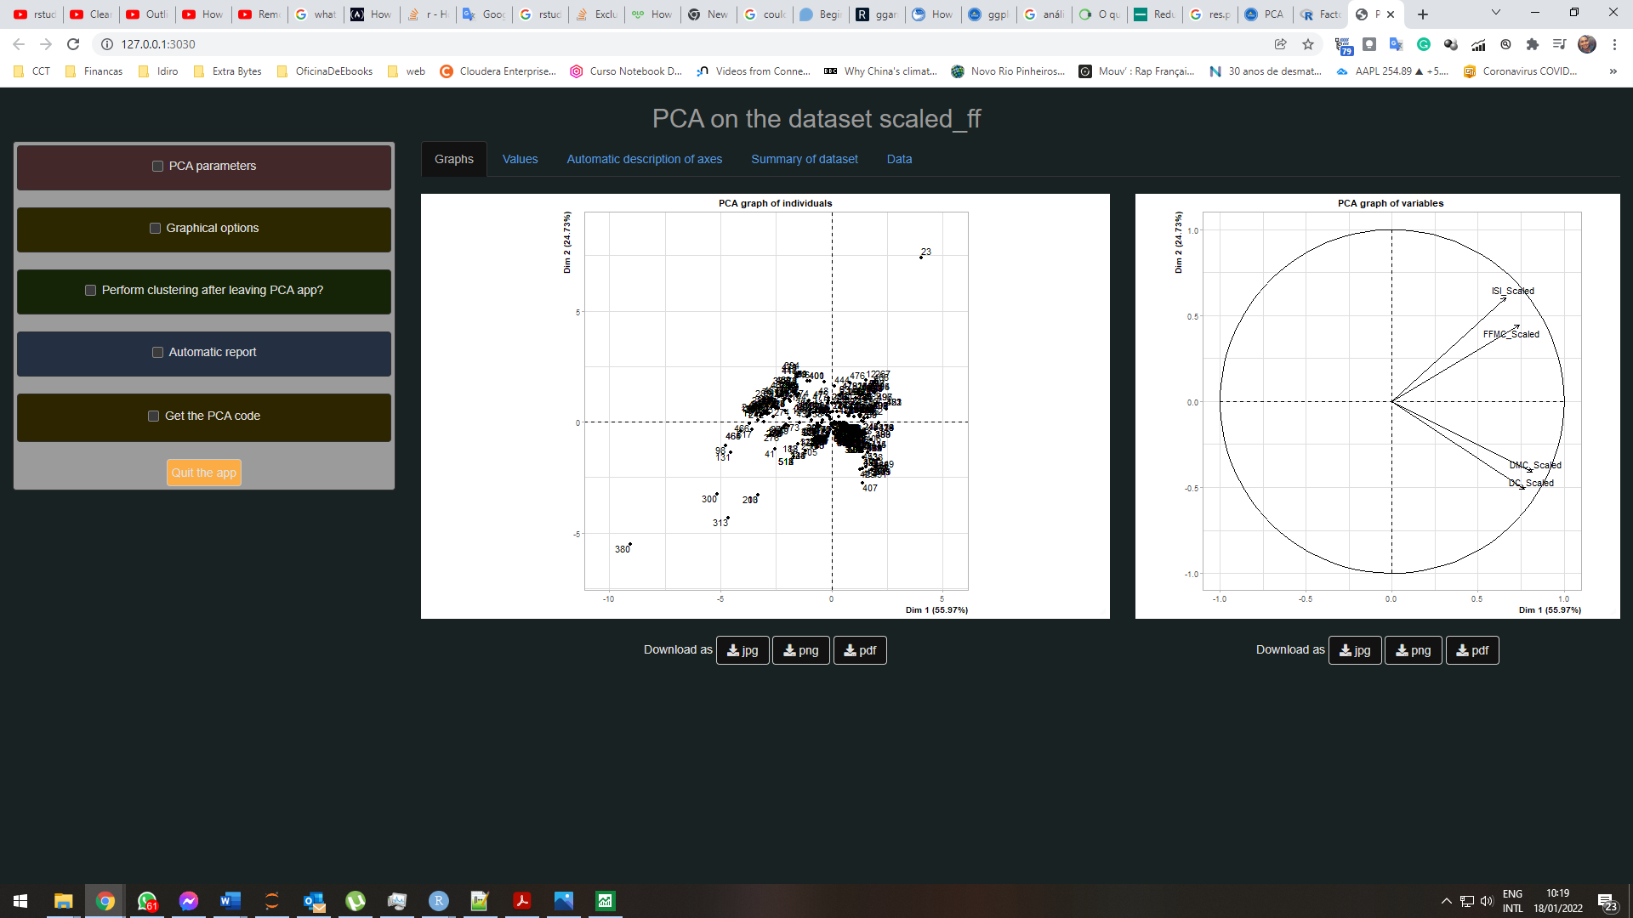

Figure 39 Performs Principal Component Analysis (PCA) a Shiny application.

HCPC graphs from the results collected from our dataset.

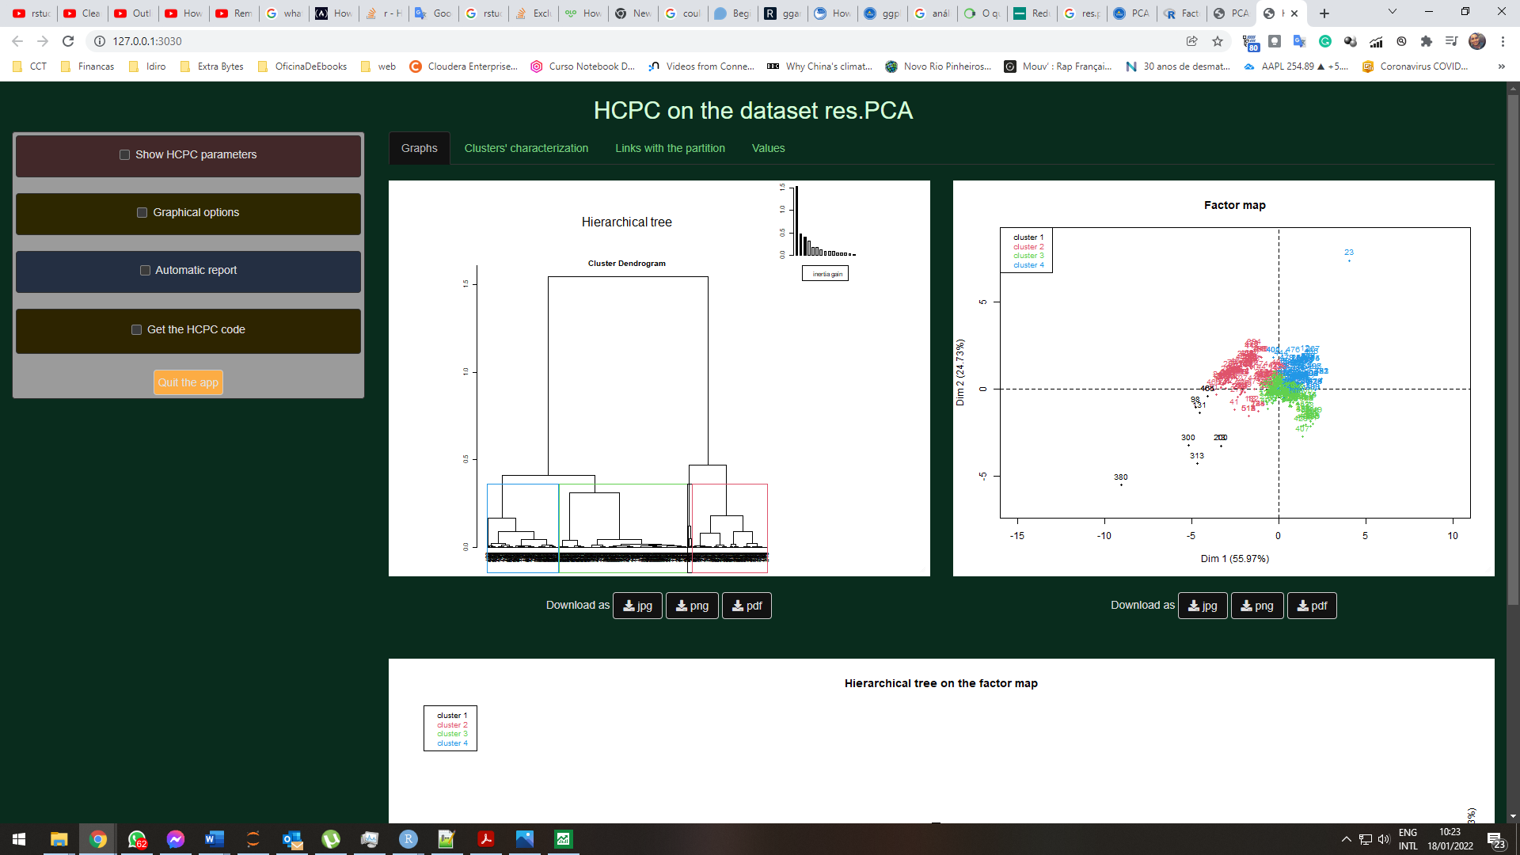

Figure 40 HCPC on the dataset res.PCA

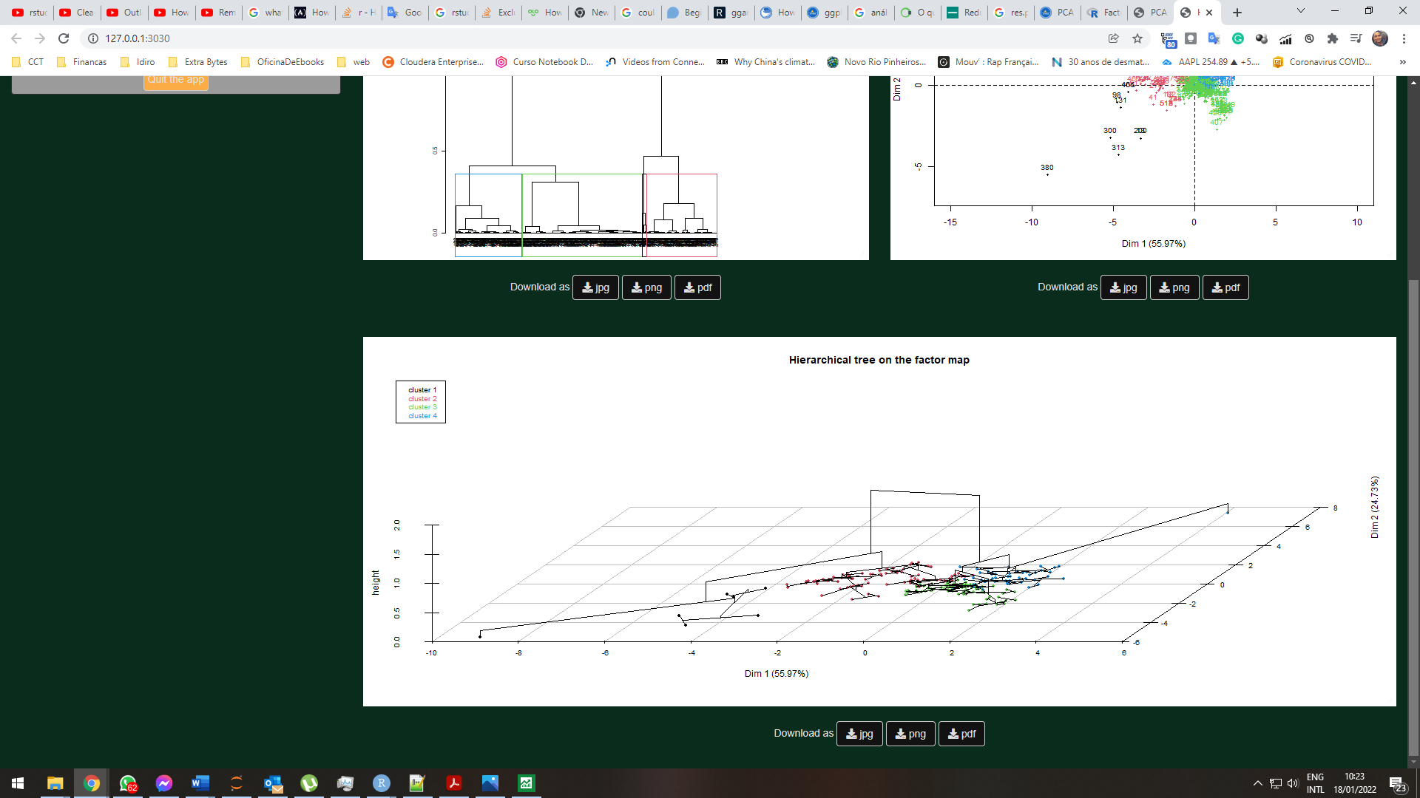

Figure 41 HCPC on the dataset res.PCA

# References

www.sthda.com. (n.d.). *Add titles to a plot in R software - Easy Guides - Wiki - STHDA*. [online] Available at: <http://www.sthda.com/english/wiki/add-titles-to-a-plot-in-r-software>.

Stack Overflow. (n.d.). *sql - R equivalent of SELECT DISTINCT on two or more fields/variables*. [online] Available at: https://stackoverflow.com/questions/2900510/r-equivalent-of-select-distinct-on-two-or-more-fields-variables/49051949 [Accessed 18 Jan. 2022].

Datanovia. (2018). *Rename Data Frame Columns in R - Datanovia*. [online] Available at: <https://www.datanovia.com/en/lessons/rename-data-frame-columns-in-r/>.

Stack Overflow. (n.d.). *r - Convert a list to a data frame*. [online] Available at: https://stackoverflow.com/questions/4227223/convert-a-list-to-a-data-frame [Accessed 18 Jan. 2022].

www.statmethods.net. (n.d.). *Quick-R: Combining Plots*. [online] Available at: <https://www.statmethods.net/advgraphs/layout.html>.

John (2020). *How to Remove Outliers in R*. [online] R-bloggers. Available at: <https://www.r-bloggers.com/2020/01/how-to-remove-outliers-in-r/>.

www.youtube.com. (n.d.). *Exploratory Data Analysis (EDA) with R*. [online] Available at: https://www.youtube.com/watch?v=niB5A8qa88I&ab_channel=Dr.BharatendraRai [Accessed 18 Jan. 2022].

www.sthda.com. (n.d.). *Combine Multiple GGPlots in One Graph - Articles - STHDA*. [online] Available at: http://www.sthda.com/english/articles/32-r-graphics-essentials/126-combine-multiple-ggplots-in-one-graph/ [Accessed 18 Jan. 2022].

Stack Overflow. (n.d.). *List distinct values in a vector in R*. [online] Available at: https://stackoverflow.com/questions/7755240/list-distinct-values-in-a-vector-in-r [Accessed 18 Jan. 2022].

Adicu.com. (2022). *Exploratory Analysis.md*. [online] Available at: https://learn.adicu.com/exp-analysis/ [Accessed 18 Jan. 2022].

Holtz, Y. (n.d.). *Basic R barplot customization*. [online] www.r-graph-gallery.com. Available at: <https://www.r-graph-gallery.com/209-the-options-of-barplot.html>.

archive.ics.uci.edu. (n.d.). *UCI Machine Learning Repository: Forest Fires Data Set*. [online] Available at: https://archive.ics.uci.edu/ml/datasets/Forest+Fires.

Stack Overflow. (n.d.). *r - Add main title multiple plots ggarange*. [online] Available at: https://stackoverflow.com/questions/65694397/add-main-title-multiple-plots-ggarange [Accessed 18 Jan. 2022].

Uminho.pt. (2022). [online] Available at: http://www3.dsi.uminho.pt/pcortez/forestfires/forestfires-names.txt [Accessed 18 Jan. 2022].

Canada, N.R. (n.d.). *Canadian Wildland Fire Information System | Canadian Forest Fire Weather Index (FWI) System*. [online] cwfis.cfs.nrcan.gc.ca. Available at: <https://cwfis.cfs.nrcan.gc.ca/background/summary/fwi>.

Uminho.pt. (2022). [online] Available at: <http://www3.dsi.uminho.pt/pcortez/forestfires/forestfires-names.txt>.

Stack Overflow. (n.d.). *rstudio - How do I transfer a variable in the “Values” section to the “Data” section in R Studio?* [online] Available at: https://stackoverflow.com/questions/45886663/how-do-i-transfer-a-variable-in-the-values-section-to-the-data-section-in-r [Accessed 18 Jan. 2022].

www.youtube.com. (n.d.). *Análise Exploratória de dados (AED) no Rstudio*. [online] Available at: https://www.youtube.com/watch?v=qAoHoD1iUwE&ab_channel=IgordeAlmeida [Accessed 18 Jan. 2022].

Statistics Globe. (n.d.). *Remove Last N Rows from Data Frame in R (2 Examples) | Delete Bottom*. [online] Available at: https://statisticsglobe.com/remove-bottom-n-rows-from-data-frame-in-r [Accessed 18 Jan. 2022].

‌

# Tasks for Data Visualisation

## Analyse the data, select appropriate visualisations to summarise the data before cleaning it and perform the same visualisations after data cleaning. Summarise any differences that you discover. Briefly explain the advantages of preparing the data for further analysis in terms of graphic presentation.

First, some Plots were performed to visualize the data contained in the dataset in its raw form. These plots range from Scatterplot, Bar, Pair Grid and BoxPlot.

As our data is untreated, we may see some distortion in the graph results.

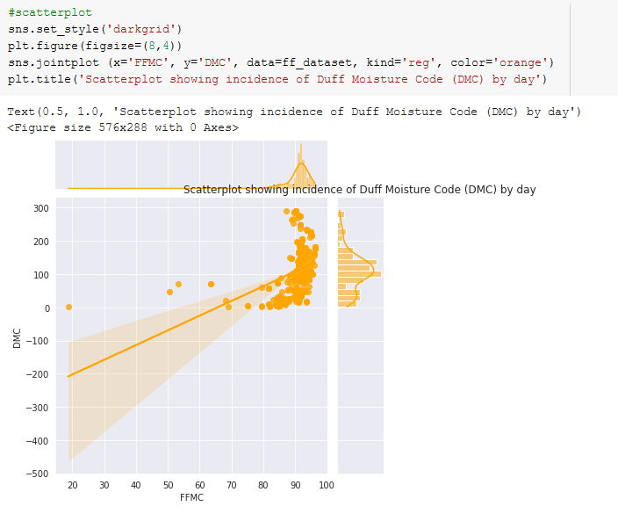

Figure 42 Scatterplot showing incidence of Duff Moisture Code (DMC) comparing with Fine Fuel Moisture Code (FFMC)

In this Box Plot, we can see the incidence of outliers. With this, we gain little space to analyze the data in detail. In this case, it is highly recommended to work with robust data close to the mean value.

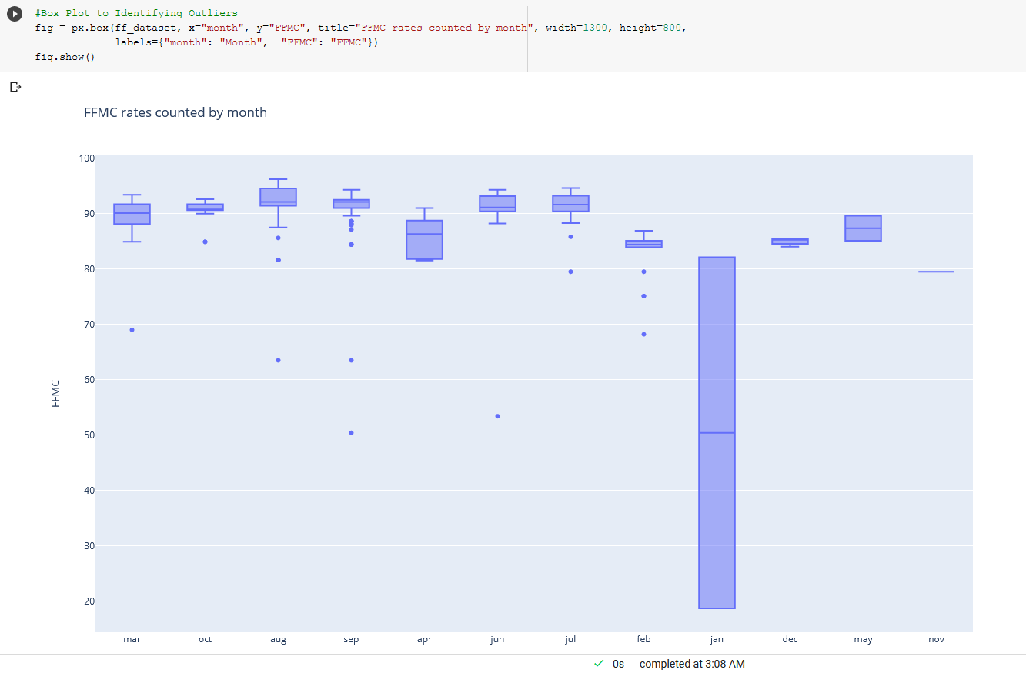

Figure 43 Boxplot for FFMC variable separated by Month.

According to the plot for the Bar, in this one, we can see the high average of incidences by Fine Fuel compounds, which are generally rubbish and abrasive materials commonly discarded by human beings. These materials quickly cause high incidences of fires and often make them uncontrollable.

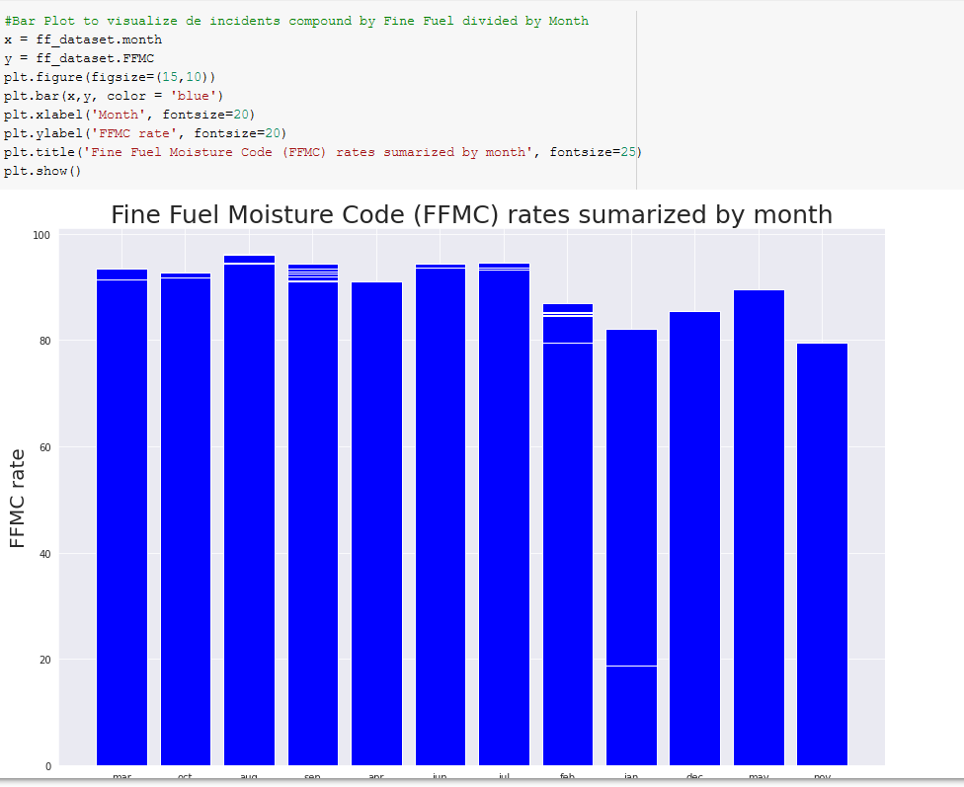

Figure 44 Bar Plot to visualize de incidents compound by Fine Fuel divided by Month

Here we can see a correlation between finely compost incident data (FFMC), organic compost (DMC), dry compost (DC), expected burn rate index (ISI) according to the results obtained from FFMC and wind speed, and finally, the total amount of burned area.

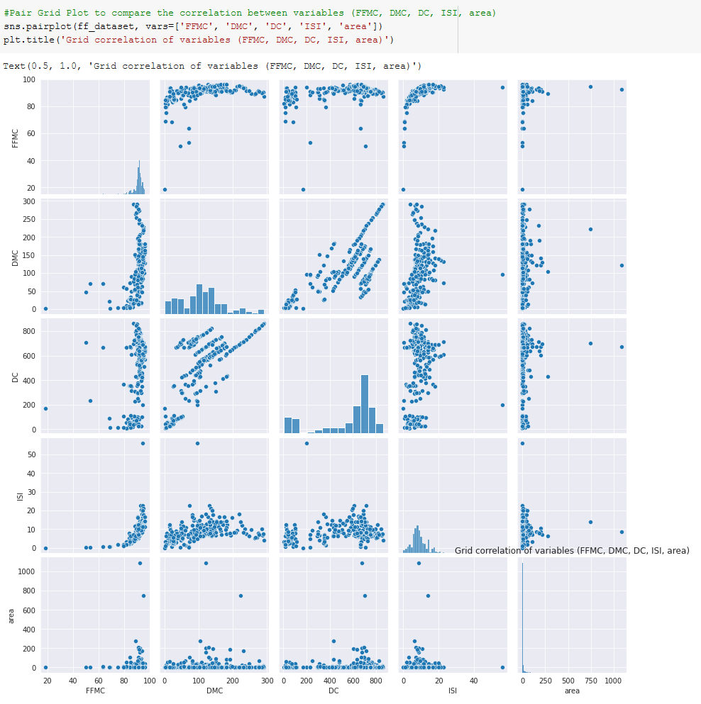

Figure 45 Grid correlation of variables (FFMC, DMC, DC, ISI, area).

At first, the dataset did not show any inconsistency in the data. Also, it was not possible to find any NA data, missing values or invalid entries such as 0 or some other value inconsistent with the dataset. However, it was necessary to carry out procedures to remove outliers, and this process was carried out in some columns, which we will explain later.

Below are some summaries of the dataset proving that we do not have any incidence of “Not available” or incorrect values:

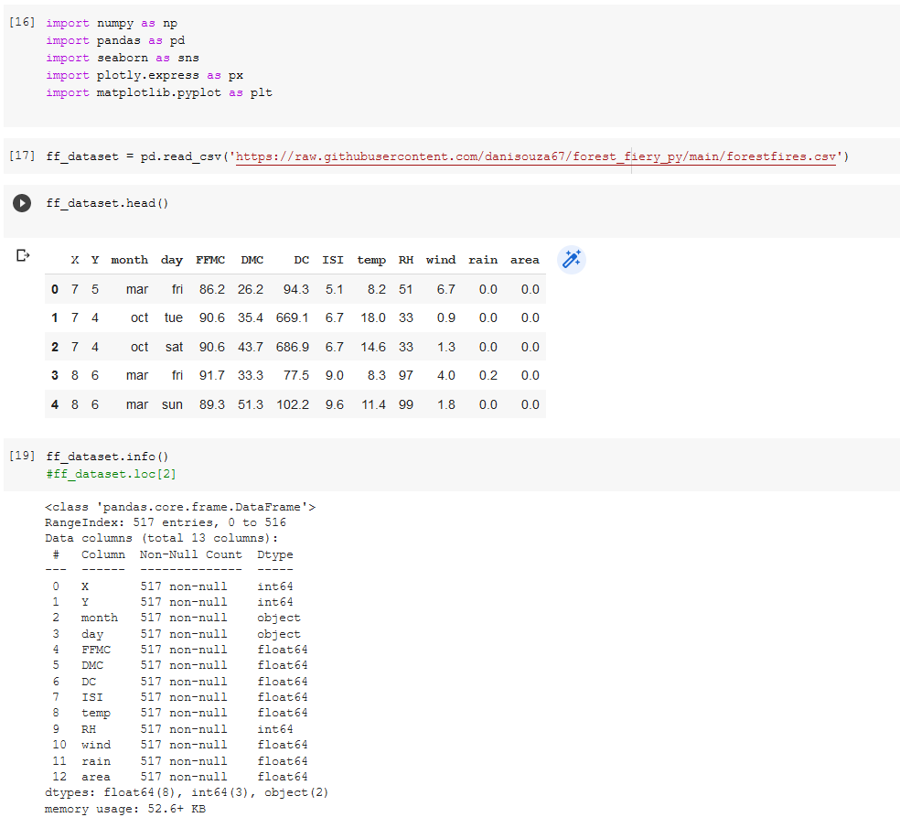

Figure 46 Summary view of information of the dataset

To start with the process of removing outliers, we will see some information about the dataset, such as mean, quantiles and others:

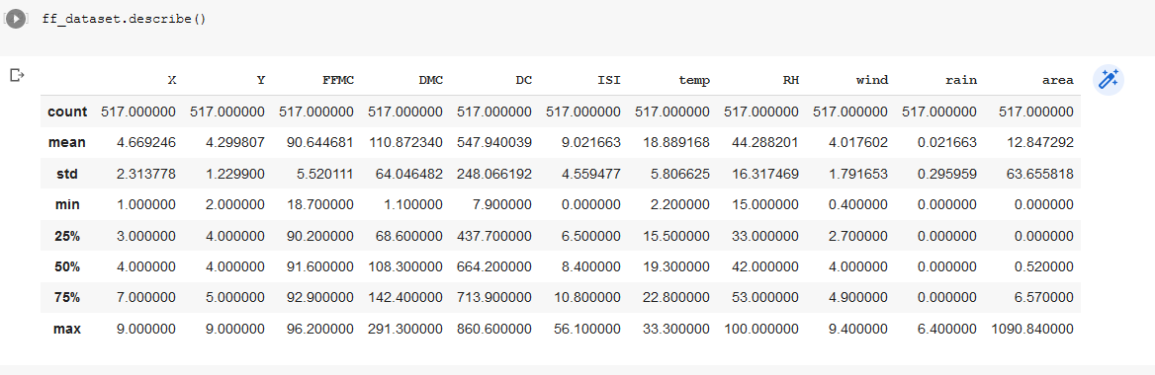

Figure 47 Describe function to show important stats about the dataset.

The process of removing outliers is quite simple. Basically, we create some functions that will dynamically handle the desired variables, returning at the end a list of observations that are outside the main scope of the data, that is, all data that have a value less than the first quantile and similarly have a value greater than the third quantile will be isolated, and we will create a clean dataset where you don't have this isolated data.

In the first view, we can see the visualization of a Box Plot with the data in its raw mode.

In the second and third parts, we develop the function that will process the data, as well as configure (through a list) the variables with which we want to work.

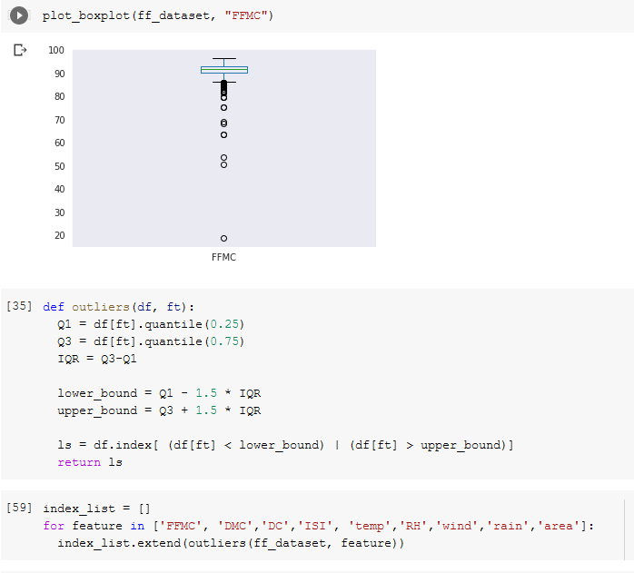

Figure 48 Box Plot with the original data, the definition of the “Outliers” function for data processing and the index list of the variables that we want to carry out this process.

In the fourth step onwards, we configure the function to remove the data processed by the “outliers” function created earlier and write only the results within the parameters to our new dataset then called “df_cleaned”. Finally, we can visualize the Box Plot of the FFMC variable already treated.

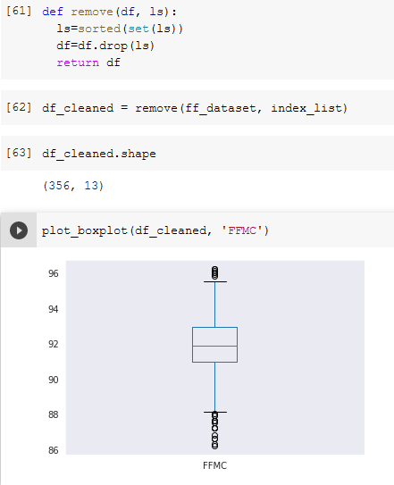

Figure 49 Function "remove" at the top, then clean the new dataset, demonstrating its shape and performing a boxplot view.

However, we can notice a difference in data treatment when they are clean and prepared for visualization or not. For example, if we had inconsistent native data like NAS or missing values, we would probably have problems generating views or requesting information about variables. Furthermore, we can have a certain distortion in the graphs when working with outliers, sometimes becoming difficult to analyze and understand. Next, see some graphs with the dataset clean and prepared for visualization.

Scatterplot with data concentrated around mean values shows a slight majority of Fine Fuel occurrences.

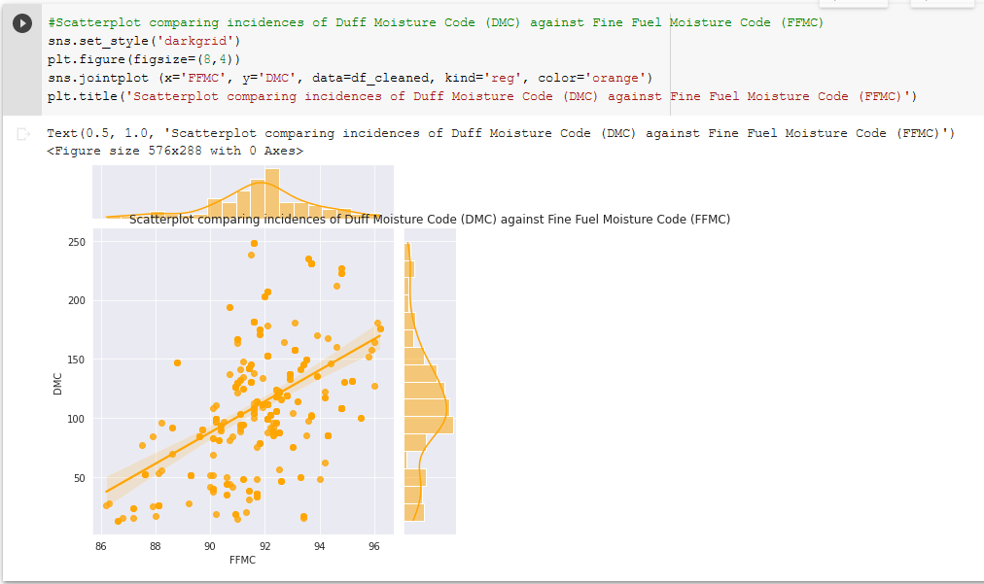

Figure 50 Scatterplot comparing incidences of Duff Moisture Code (DMC) against Fine Fuel Moisture Code (FFMC).

Our Bar Plot did not show much difference from the original data.

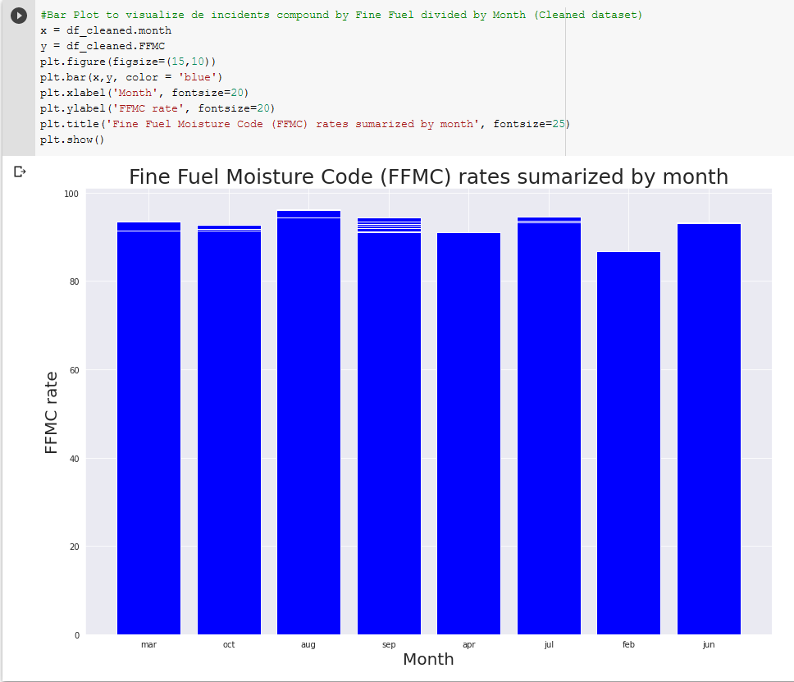

Figure 51 Fine Fuel Moisture Code (FFMC) rates summarized by month.

Here we were again able to compare the correlations of the variables FFMC, DMC, DC, ISIS and area using the Pair Plot provided by Seaborn. In this case, we remove the outliers.

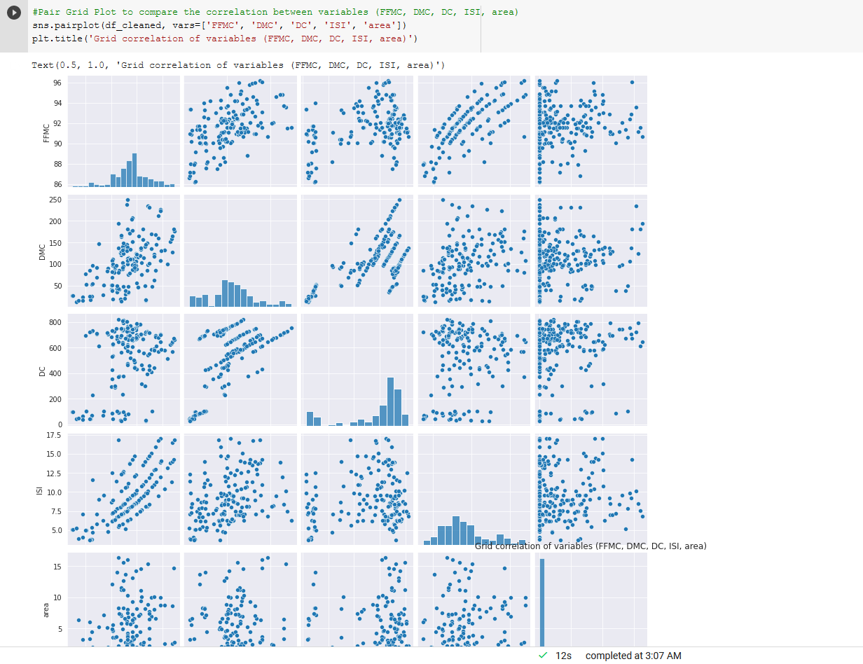

Figure 52 Grid correlation of variables (FFMC, DMC, DC, ISI, area).

Box Plot more concentrated with isolated values close to the mean value.

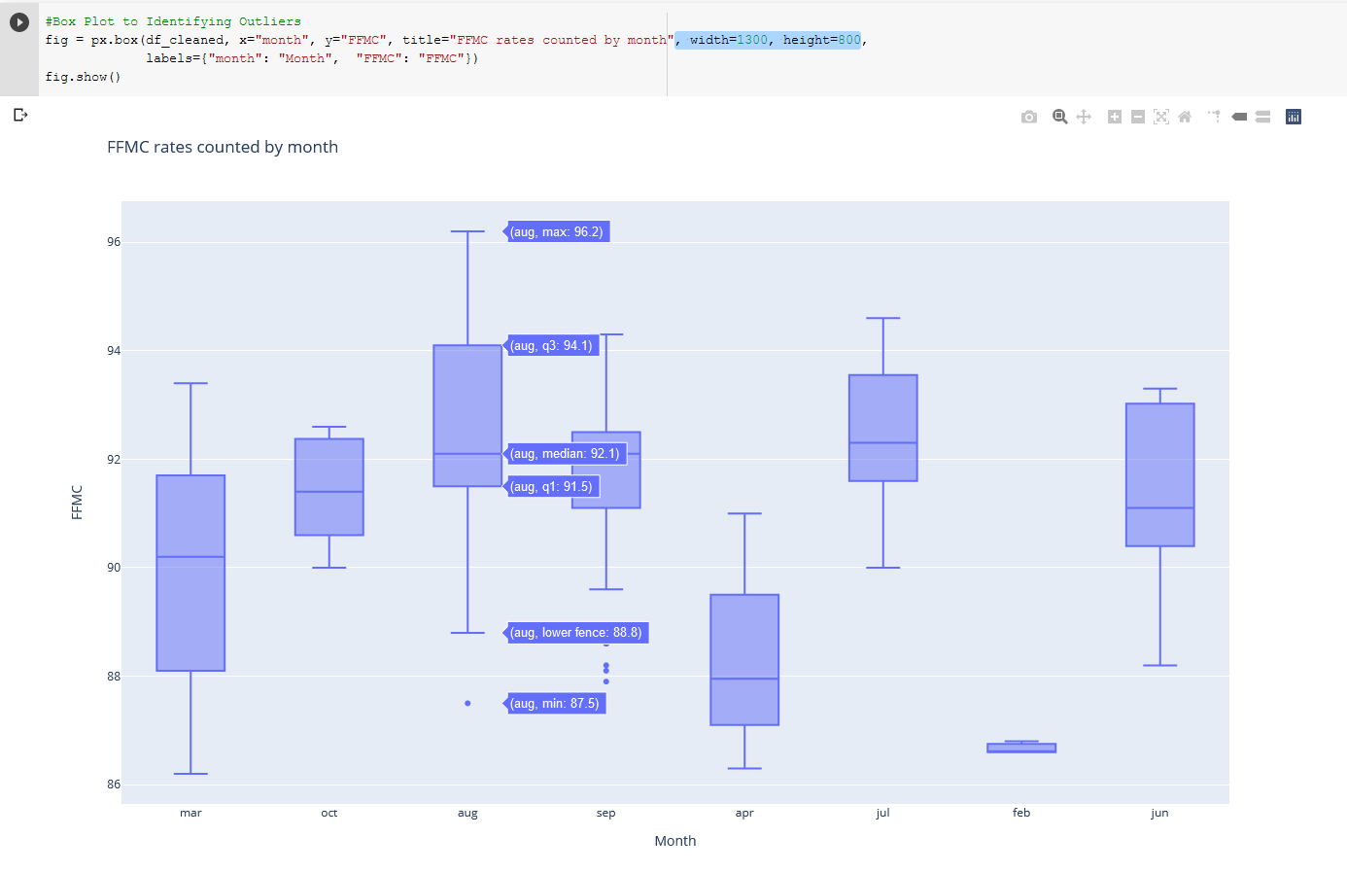

Figure 53 Box plot FFMC rates counted by month

## Use more than one interactive visualisation to highlight any impact that forest fire has on the environment. You are required to use additional data and merge it with the dataset provided to complete this task.

In this case, to do a more advanced exploratory analysis, we need to identify some key factors, patterns and trends, which are only possible to achieve by statistical engineering methods. Let us analyze this next.

In this Bar Plot, we want to compare the average amount of burned area per day of the week to get an idea of the busiest days for the poor trees.

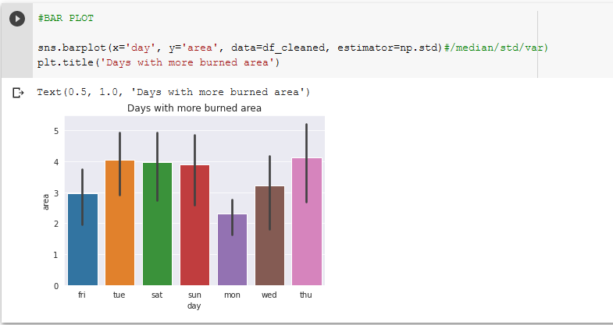

Figure 54 Days with more burned area

In this next Bar Plot, we can see the months with the greatest burned areas, September, August, and July.

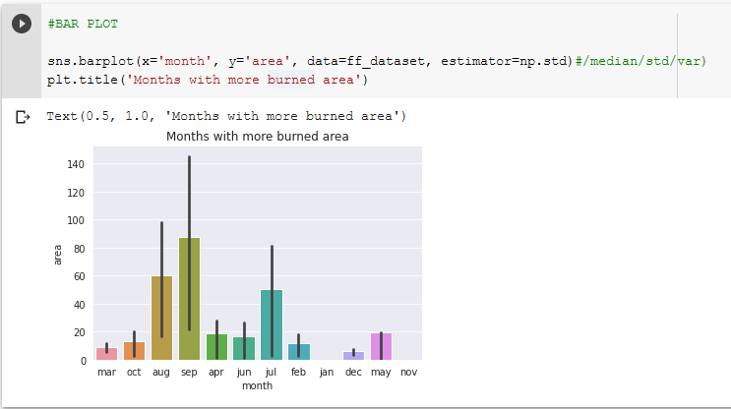

Figure 55 Months with more burned area

Next, we will count the number of fires that occur per day of the week, and this factor is critical to realize that the incidences occur on a larger scale on days when they do not have more significant work routines than those who take care of the forest park itself.

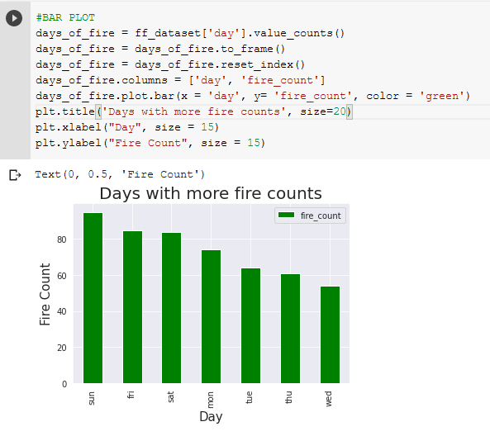

Figure 56 Days with more fire counts

Here we look at how much temperature influences burnt areas in general, and as a result, we can see a higher incidence of the burnt area when the temperature rises a little higher.

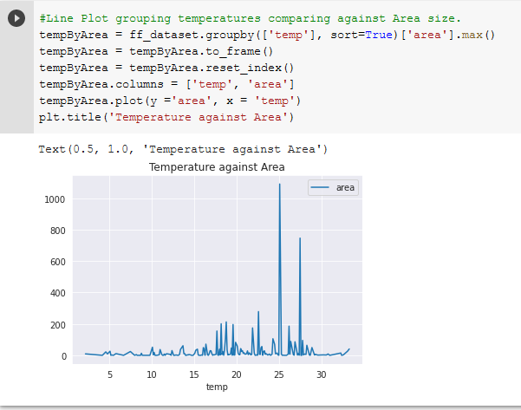

Figure 57 Temperature against Area

Finally, we check the correlation between the variables to find possible relationships between them. Values of this result closer to 1 mean a strong correlation.

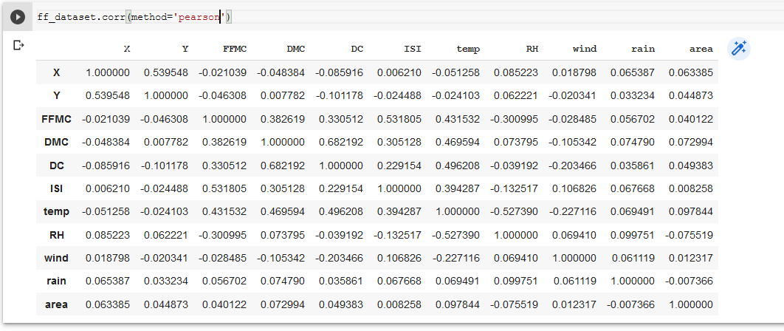

Figure 58 Correlation between all variables.

In order to achieve better processing performance when working with Machine Learning, we must consider that ML modules work best when categorical data are separated among all categories, and binary records are used in their respective value. That makes the dataset more understandable for computers. In our case, we will apply the Hot Encoding technique to all available categorical variables. See below:

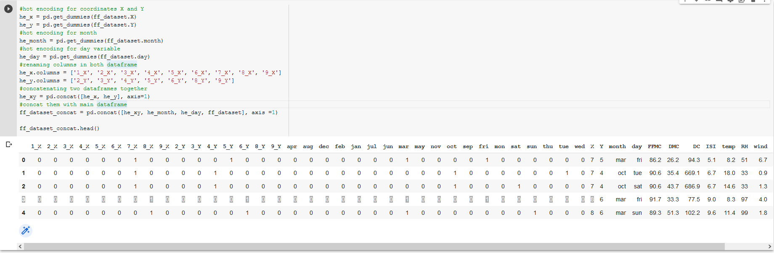

Figure 59 Hot Encoding being applied to all categorical variables.

To work with machine learning, our next step would be to convert the unit values of some variables to a unit more related to the others that are making up the data frame. In this case, we will convert the temperature variables (from degrees Celsius to Fahrenheit) and wind speed (from kilometres per hour to meters per second):

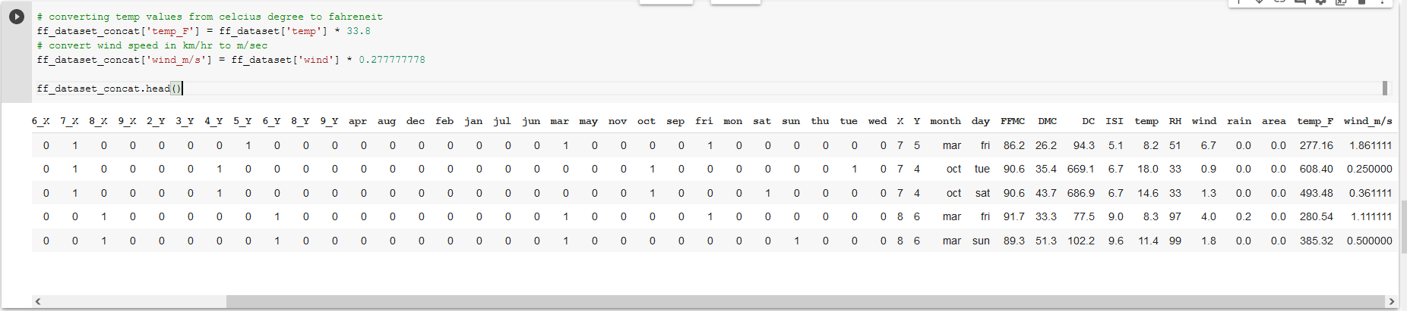

Figure 60 Applying One Hot Encoding function for categorical variables.

As described before, Binary Encoding represents memory efficiency and doesn't require much to create. To reduce dimensionality, we will create a column that will inform the observations that belong to the weekends.

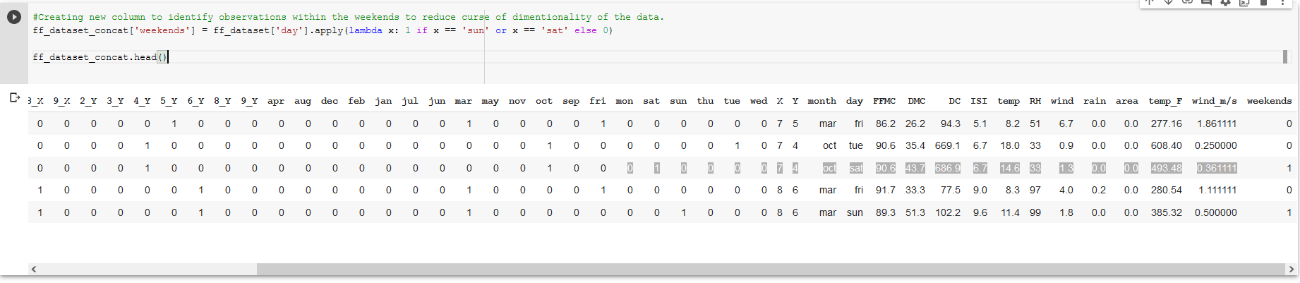

Figure 61 Short Output of the new dataset with variables separated.

Here we start the task to work the dataset with Machine Learning. The program will check all the variables, performing a thousand times calculations on each variable. It is crucial, at this point, for the dataset to be appropriately cleaned and prepared to optimize processing time.

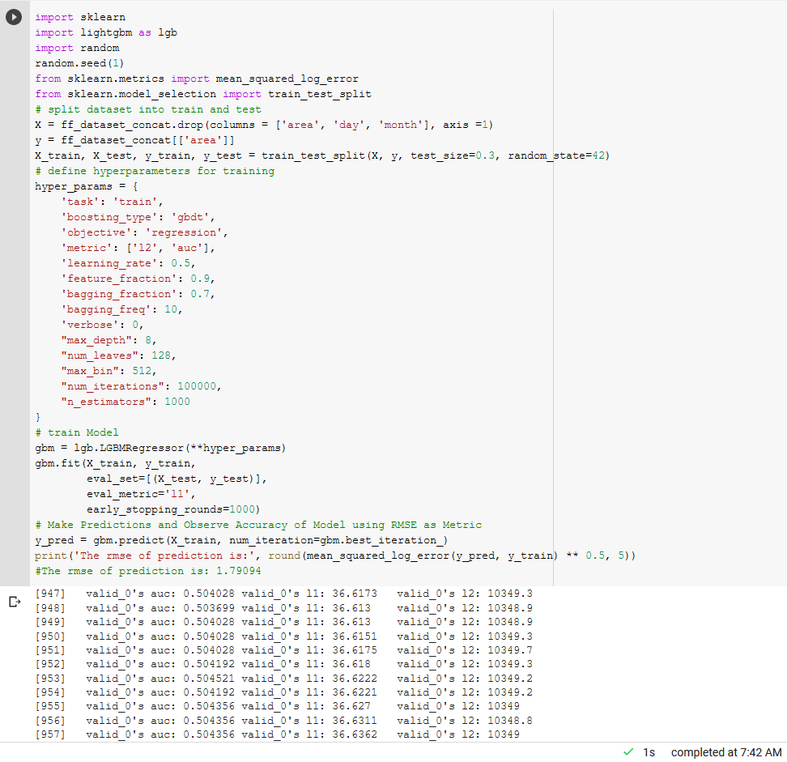

Figure 62 Initiating the dataset learning and prediction process.

Here we can see the result of the process started above.

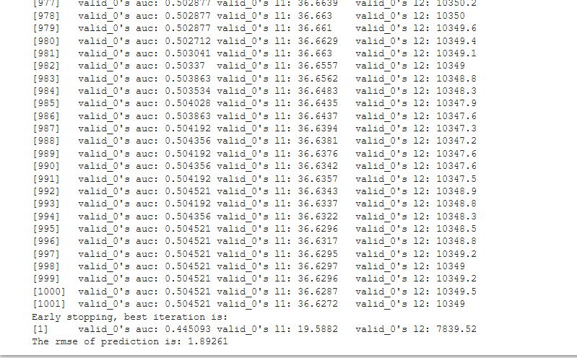

Figure 63 Result of RMSE prediction.

## Compare and contrast at least two different visualisation libraries that you used to complete the tasks of this assignment. Detail the differences and/or similarities between these libraries. Rationalise your design choices such as colour selection, font size, use of white spaces, etc...

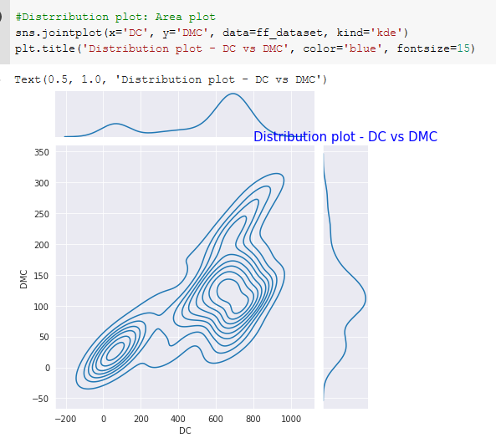Seaborn

The landscape of Python libraries is rich, and they often overlap. So, where are we now? Seaborn is built on top of Matplotlib, and they work well together when exploring data visually. The package is oriented towards statistical graphs and offers many functions starting with confidence interval or kernel density estimation, known as KDE. We will explain these terms later. Also, Seaborn works well in conjunction with Pandas and its DataFrame framework.

We can say that Seaborn is a statistical extension of Matplotlib. The library comes with several functions to help better understand the data. The library puts data visualization and exploration at the heart of data analysis. One of the things making the package exceptional is the broad spectrum of graphs available for analyzing relationships between multiple variables. Seaborn also works well with categorical variables and shows aggregate statistics and count charts.

Other exciting features are bivariate graphs and multiplot grids. These are great tools to understand underlying relationships not visible in tabular data. We can immediately see the correlation between multiple variables.

Also worth mentioning is the style and general look and feel of the analyzed dataset. The variety of different background styles, colour palettes, and other customization features will increase the understanding of data for any audience. We need to communicate our findings accurately and appropriately to make insights impactful. Seaborn has practical tools to support this.

Seaborn and Pandas

Seaborn is great to work well with Pandas Dataframe. It is important to mention that a dataset for Pandas must be organized and tidy. Each row represents an observation in an organized dataset, and each column is a variable, often called a feature. If we want the library to work correctly, the first look and understanding of the data are crucial. To determine if the dataset is tidy, try using the .head() and .tail() methods.

Seaborn vs. Matplotlib

If ever seen the abbreviation SNS in python code, it refers to Seaborn. Importing it is as simple as any other python library. Along with seaborn, we also need to import Matplotlib lib Pyplot to take advantage of the synergy of both. Even though most of the work can be done by sea, Matplotlib adds some parts of its functionality.

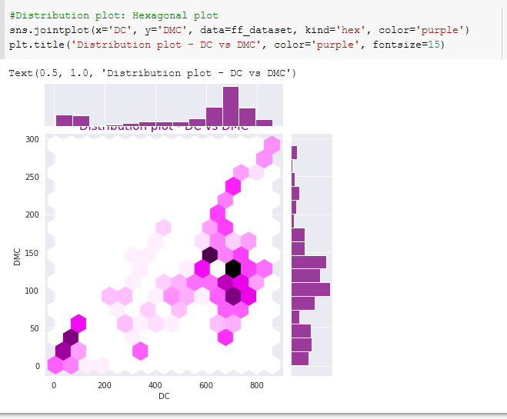

Figure Representation of Seaborn, collecting data from Forest Fire dataset.

Figure 65 Representation of Seaborn, collecting data from Forest Fire dataset.

# References

www.columbia.edu. (n.d.). *ForestFire*. [online] Available at: http://www.columbia.edu/~yh2693/ForestFire.html [Accessed 18 Jan. 2022].

Canada, N.R. (n.d.). *Canadian Wildland Fire Information System | Examples of Fire Behavior in Jack Pine Stands*. [online] cwfis.cfs.nrcan.gc.ca. Available at: <https://cwfis.cfs.nrcan.gc.ca/background/examples/fwi>.

pythonbasics.org. (n.d.). *Seaborn pairplot example - Python Tutorial*. [online] Available at: <https://pythonbasics.org/seaborn-pairplot/#:~:text=A%20pairplot%20plot%20a%20pairwise>

Cortez, P. and Morais, A. (n.d.). *A Data Mining Approach to Predict Forest Fires using Meteorological Data*. [online] Available at: <http://www3.dsi.uminho.pt/pcortez/fires.pdf>.

Canada, N.R. (n.d.). *Canadian Wildland Fire Information System | Examples of Fire Behavior in Jack Pine Stands*. [online] cwfis.cfs.nrcan.gc.ca. Available at: https://cwfis.cfs.nrcan.gc.ca/background/examples/fwi [Accessed 18 Jan. 2022].

Schafer, C. (2022). *code_snippets*. [online] GitHub. Available at: https://github.com/CoreyMSchafer/code_snippets/blob/master/Python/Pandas/09-Cleaning-Data/Pandas-Demo.ipynb [Accessed 18 Jan. 2022].

www.youtube.com. (n.d.). *How to remove outliers in Python? | For multiple columns | Step by step ♥*. [online] Available at: https://www.youtube.com/watch?v=Vc4cXIAa69Y&ab_channel=EigenBfromHomeworkers [Accessed 18 Jan. 2022].

www.youtube.com. (n.d.). *How to remove outliers in Python? | For multiple columns | Step by step ♥*. [online] Available at: <https://www.youtube.com/watch?v=Vc4cXIAa69Y&ab_channel=EigenBfromHomeworkers>.

Ridley, M. (n.d.). *Amara’s Law*. [online] www.rationaloptimist.com. Available at: https://www.rationaloptimist.com/blog/amaras-law/ [Accessed 18 Jan. 2022].

Journey to AI Blog. (2019). *What is the impact of data science automation?* [online] Available at: https://www.ibm.com/blogs/journey-to-ai/2019/04/what-is-the-impact-of-data-science-automation/ [Accessed 18 Jan. 2022].

Oiti. (2021). *Data Mining: Etapas e benefícios*. [online] Available at: https://www.oititec.com.br/data-mining-etapas-e-beneficios/ [Accessed 18 Jan. 2022].

‌

Jordan, T.R., Welle, T. and Byrne, M.D. (2013). Comparison of Manual versus Automated Data Collection Method for an Evidence-Based Nursing Practice Study. *Applied Clinical Informatics*, 04(01), pp.61–74.

‌

# Tasks for Artificial Intelligence

## In honour of the hard work that the fire officers are doing, the community has decided to build a new fire station for them. There are seven fire officers and four offices. Because there are more fire officers than offices, some fire officers have to be in the same offices as others. However, the fire officers are very picky about who they share with. The community administration is having trouble assigning fire officers to offices. They have asked you to plan where each fire officer goes. Using any CSP (Constraint Satisfaction Problem) framework, discover if the above problem can be solved and if so, detail who would be in each office.

The Satisfaction of Constraints will solve this problem because it uses a very particular method, where if any constraint occurs, it is not satisfied. If the process generates an error in the middle of the way, the program will return to the previous variable and try to change the domain. If satisfying the program, the condition continues; if not, it will return another variable. See the implementation of this program below:

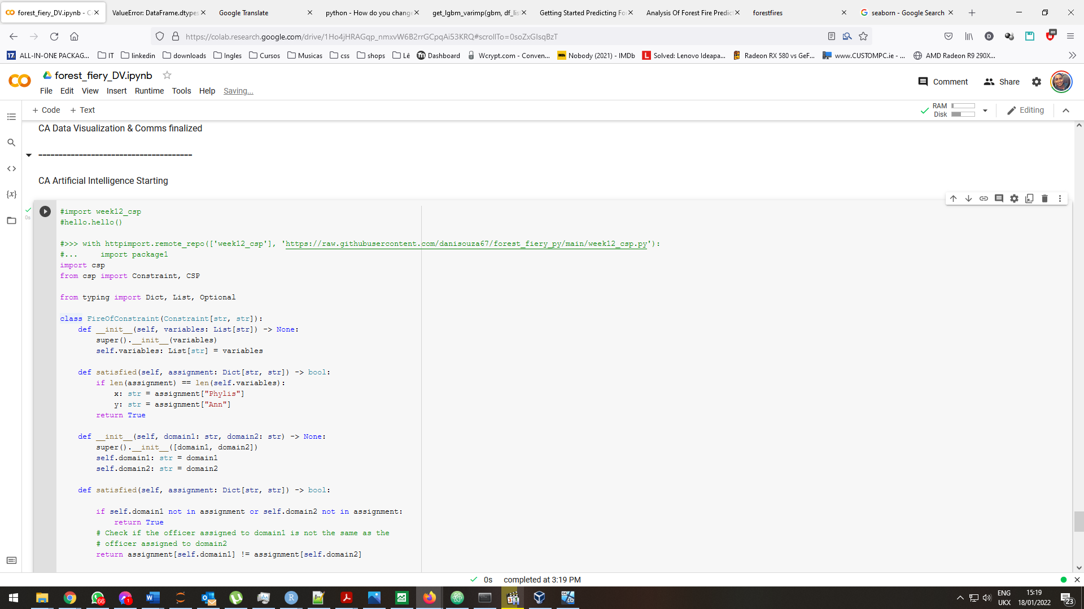

Figure 66 First part of the program where we load the libraries and create the class where all constraints will be processed.

In the second part, will locate the variables, domains and constraints themselves.

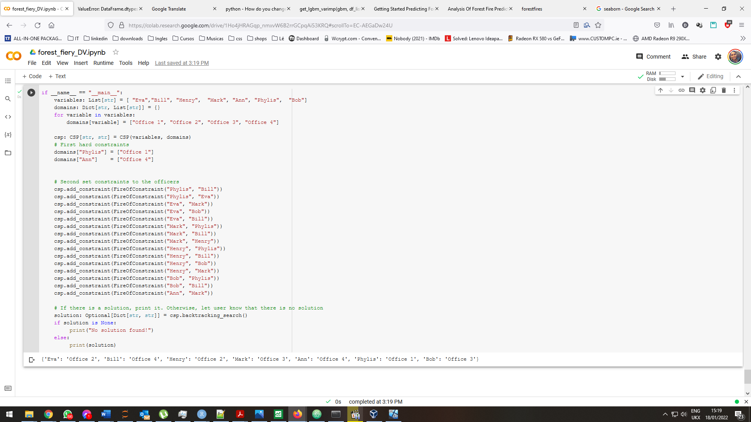

Figure 67 Second part of the program, where the data we want to work with are concentrated.

## Discuss in detail how using Constraint Satisfaction finds an answer or finds no solution to the problem in Tasks for Artificial Intelligence part 1. How does this differ from standard algorithmic solutions?

When we discuss problems with constraints to achieving a certain goal, they all have something in common. The solution for them is the satisfaction of a series of constraints.

In artificial intelligence we can find several modules that are somewhat complex, but once the solution fits the problem we don't have to worry about the code in the modules, but with the restrictions themselves. The state is self-contained, that is, it is a kind of black box that does not often interest us what is in each part of the state, or each component of the state. We are simply interested in knowing whether the state is a goal or not, that is, whether we have reached a goal state or not.

Each of these variables with their respective particularities and the goal that we are going to establish for the solution of our problem is simply a set of restrictions to be satisfied. Looking at the completed task question above, we have as an example a set of firefighters that we must allocate in a smaller amount of offices than the current number of firefighters. It would be easy to solve this with a simple depth search if it was just this request. But many of the firefighters have critical restrictions for the program's operation, and this solution will not be possible with depth searches. We need to work with constraints, a unique feature of CSR.

The program's process is to load the necessary libraries and then build its modules, which is the heart of the program, but we don't need to tinker with it too much for our solution. Mostly in the second part, where the program starts and loads the desired information, constraints, and so forth.

For this solution, we fill in a List of variables (which are the names of the firefighters). Then we can take care of the domains of the variables, which are the offices, and when we initialize the hard constraints first, we are configuring the constraints that will stay static and will not change. Then we can work with the construction of the requests, the order here doesn't affect that much, but make sure that both people are properly registered in the set of constraints. The program will interpret the two names received and this is the essential factor for the program to adapt each firefighter in their respective room.

## Can this problem be solved using any other algorithm we have studied in the module? Discuss your answer in detail including a proof of your hypothesis.

The algorithms studied in the module are somewhat similar to each other, like the Mix Max algorithm and the search with heuristics, they have traits that could come close to solving this problem, but in my view, the only solution that adequately satisfies this set of constraints is the CSR itself. We can consider the PSR solution, but we will be able to implement it more easily, in this case, the Constraint Satisfaction solution.

# References

Stack Overflow. (n.d.). *How can a Python module be imported from a URL?* [online] Available at: https://stackoverflow.com/questions/28300915/how-can-a-python-module-be-imported-from-a-url [Accessed 18 Jan. 2022].

GitHub. (n.d.). *django 1.9: cannot import name “Constraint” · Issue #349 · deschler/django-modeltranslation*. [online] Available at: https://github.com/deschler/django-modeltranslation/issues/349 [Accessed 18 Jan. 2022].

www.roseindia.net. (n.d.). *ModuleNotFoundError: No module named “csp.”* [online] Available at: https://www.roseindia.net/answers/viewqa/pythonquestions/67439-ModuleNotFoundError-No-module-named-csp.html [Accessed 18 Jan. 2022].

Littman, M., Sutton, R. and Singh, S. (n.d.). *Predictive Representations of State*. [online] Available at: https://web.eecs.umich.edu/~baveja/Papers/psr.pdf [Accessed 18 Jan. 2022].

B, J. (2022). *About*. [online] GitHub. Available at: https://github.com/janeczku/calibre-web/blob/master/cps.py [Accessed 18 Jan. 2022].

www.youtube.com. (n.d.). *What is Constraint Satisfaction | Constraint Satisfaction Problem(CSP) in AI with Example*. [online] Available at: https://www.youtube.com/watch?v=AgyCSmDVk5s&ab_channel=GateSmashers [Accessed 18 Jan. 2022].

stringfixer.com. (n.d.). *Problema de satisfação de restrição*. [online] Available at: https://stringfixer.com/pt/Constraint_Satisfaction_Problem [Accessed 18 Jan. 2022].

‌

Utcke, M. (n.d.). *deepend: Advanced end-to-end machine learning framework.* [online] PyPI. Available at: https://pypi.org/project/deepend/ [Accessed 18 Jan. 2022].

‌ktiml.mff.cuni.cz. (n.d.). *Constraint Guide - Alternative/General Approaches*. [online] Available at: https://ktiml.mff.cuni.cz/~bartak/constraints/general.html [Accessed 18 Jan. 2022].

‌